Standard 3: Mission, Goals and Evidence of Achievement of Student Affairs Offices

Athletics and Recreation

Athletics and Recreation Mission Statements

At Evergreen, intercollegiate athletics and recreation are housed in a unified Athletics & Recreation Department. Each of the major functions has its own mission statement and corresponding goals.

- The mission of Evergreen's Intercollegiate Athletics program is to provide opportunities for students to compete at the intercollegiate level in a variety of sports that are appropriate for Evergreen.

- The mission of Evergreen's Recreation program is to promote and facilitate traditional and non-traditional recreation opportunities for the benefit of the campus community.

Several key goals were set during the 1998-2008 accreditation period for each function, as well as for the upgrading of our facilities for both the intercollegiate and recreation programs. These included:

Intercollegiate Athletics: Goals and Accomplishments

To find an appropriate level of play and organizational and conference home:
Although a long-time member of the National Association of Intercollegiate Athletics, Evergreen was caught up, along with nearly every non-NCAA Division I school in the Northwest, in a shake-up in national affiliations during the late 1990s. The determination was made to join NCAA Division III. Ultimately, Evergreen could not find a conference home in that organization, so determined to return fully to NAIA membership. This has worked out very well, with membership in one of that body’s thriving leagues, the Cascade Collegiate Conference serving as the focal point of Geoduck sports since 2000.

To compete at a high level within the NAIA:
This goal has been achieved in demonstrable fashion. Prior to 1998, Evergreen had never reached a national championship tournament in a team sport. Since that time, men’s basketball reached the final 16 in 2002 and men’s soccer reached the final 8 in 2004. In 2008, men’s basketball hosted the Cascade Conference championship game for the first time. Throughout the decade, individual athletes in various sports have also reached national competition. In the college’s history, 17 student-athletes have been named to an NAIA All-America team. Fourteen of these have played since 1998.

Recreation: Goals and Accomplishments

To offer an array of programming to meet the needs of the campus community:
While a work in progress, there have been several successes in this area. Among them have been a successful revival during the 2008-09 academic year of intramural sports, the ongoing success of Geoduck sport club teams including men’s baseball and women’s crew and an array of recreational “Leisure Education” courses that include a variety of activities from yoga and martial arts to dance.

To focus more professional staff time and development on the recreation area:
The Associate Director of Athletics and Recreation was tasked to fully supervise and develop recreation. Significant research was done by both the Associate Director and the Athletics & Recreation Facilities and Events into best practices and operational procedures at the other five campus recreation centers and several changes made to Evergreen’s operation as a result.

Facilities: Goals and Accomplishments

To constantly monitor the state of Evergreen’s athletic and recreation facilities and to create improvements when possible. The following are highlights of this philosophy in action during the 1998-2008 period:

- Workout areas, once spread throughout the College Recreation Center, have been consolidated for more coherent use by patrons. Obsolete equipment was disposed of during 2000-2002 and updated throughout the last eight years.
- A new dance floor surface was installed in one studio. Another was segemented and its use dedicated to yoga on one side and an expanded cardio equipment area on the other.
- The main soccer field playing surface was regraded during spring/summer 2008 to go with previous improvements to the scoreboard and sound system.
- The “Covered Recreation Pavilion” went from having a slippery concrete floor to being the only semi-indoor artificial turf facility in the area in 2004.
- The main basketball game court was stripped of extraneous lines and repainted with a more attractive striping plan and renderings of the Geoduck mascot.
- Gender neutral rest rooms/showers were installed in the CRC.
- New floor coverings were installed in key CRC areas such as locker rooms, the climbing gym and weight-lifting areas.

Enrollment Services – Admissions

Admissions Office Mission Statement
Evergreen’s Admissions Office mission is to expand the college's visibility to specific and targeted audiences; to explain Evergreen's interdisciplinary curriculum consistently and accurately to each audience; to increase the sophistication and effectiveness of it's recruitment strategies; and to respond to inquiries and applicants in a timely manner with clear and timely communication and excellent customer service.

Recent Goals and Achievements of the Admissions Office

- Significant institutional support in terms of budget and shared mission: The recruitment effort has received substantial budget support from the College allowing improvements in quality and quantity of our work. Recognition of the importance of student recruitment and a sense of shared responsibility for this work extends across the institution.
- Overhaul of publications and development of a targeted mailing series: In 2001, the “mailing series” to students inquiring about enrollment consisted of one packet containing the College Catalog, an Application Form and a letter from Admissions. In 2006, the mailing series consists of 15 different pieces sequenced and with content intended to move a student from inquiry to applicant to admitted to enrolled status. The series contains high-end publications (e.g., the general Viewbook, Academic Viewbook, Transfer Guide, and Visit Evergreen Brochure) and a series of postcards reminding students of important upcoming enrollment events (e.g., Fridays at Evergreen; President’s Receptions). Strategies have been developed that employ an intentional communications plan to direct the recruitment mailing series, and of equal importance, have secured a reliable delivery system for the mailing series.
- Comprehensive follow-up efforts: Mail, telephone, web/e-mail and personal contacts with prospective students by Admissions counselors and staff, current students and Evergreen faculty have increased, including students-to-students tele-counseling telephone calls.
- Twenty-four hour response time: In recognition of the importance of timeliness, any e-mail, written, or telephone communication receives a response within 24 hours. Campus visitors are sent a “thank you for visiting” card within twenty-four hours.
- College web site redesign and web support staffing: The College’s web site was redesigned in 2001 with special emphasis on improving communication with prospective students. Funding was provided for staff to maintain and improve the web site the following year. Improvements have continued since then as managed from the College Relations Office in coordination with Enrollment Services. Enrollment Services staff also update and improve the Admissions and Financial Aid web sites on a regular basis.
- Remodel of the Admissions Office: The space was an eyesore for students and parents in comparison with other schools visited such as UPS, Reed, and Lewis and Clark. The remodel in 2002 provided temporary improvements. As the Library Phase II remodel enters its second phase, enrollment services has taken an active role during the design phase to ensure a general upgrade of appearances in Admissions. In addition, efforts are being made to accommodate guests during the remodel period and temporary move to Seminar I.
- Articulation agreements: Additional articulation agreements to promote easier transition from community colleges in Washington to Evergreen continue to be negotiated (more fully described in the Resident Community College Transfer section).
- Reorganization of Classified Employees: All classified employees in the office were reclassified as credential evaluators. Two factors prompted this effort: 1) staff previously classified as office assistants were impacted and “bumped” out of their positions during budget cuts; and 2) the old system promoted a division of labor that broke down during absences. Students often did not get an official transfer credit evaluation until well into the quarter for which they had applied. With each credential evaluator assigned to a section of the alphabet, all applications are now reviewed and awarded transfer credit prior to registration.
- Reorganization of Admissions Counselors: Whereas a division of labor was counterproductive to the classified staff responsibilities as described above, a division of responsibilities is essential to the relationship-building and long-term outcome strategies for the admissions counselors and the target audiences with whom they work. As the organizational chart indicates, each counselor now has a specific recruitment responsibility (e.g., non-resident recruitment, Student Visitor Program, etc.).
- Capping non-resident tuition: Resisting pressure to increase non-resident tuition during the past two years has allowed us to recover some of the competitive advantage in cost lost to private institutions when tuition increased substantially from 2002 - 2004. Each year non-resident tuition is not increased the College’s position on cost relative to the private school competition is improved.
- Tuition waivers in the form of “Scholastic Achievement Awards” (SAA): During the past two years, the College has provided new financial support to students aimed at making Evergreen a more competitive choice among the selective liberal arts colleges with whom it competes for non-resident freshmen. This new strategy of “tuition discounting” has clearly been successful attracting and enrolling students who would otherwise have opted for institutions providing stronger financial aid packages.
- Technological improvements and efficiencies: With the conversion to Banner and annual contracting for supplemental software with NOLIJ Recruit and CollegeNet On-line Application being phased out (supplemental software contracts added approximately $35,000 in costs annually) with the 2007 conversion to Banner Recruit and Banner Apply, tools were added and upgraded to permit students to apply in a timely manner (88% apply on-line) and to provide staff with a tool to more easily input and systematically manage recruit information.
- Emphasis on the Campus Visit: Recruitment literature emphasizes that the campus visit has the greatest impact on a student’s choice of colleges. Evergreen has restructured its messages to prospective students to direct them toward a campus visit and have greatly improved the sophistication and quality of our Campus Visit Program. The addition of “visit” pieces crafted for different recruitment events and audiences, a Student Visitor Program Coordinator, improved data collection, a well-scripted program, and an on-line visit calendar, have led to a substantial increase in the number of students visiting Evergreen and improvement in the quality of their visit. For Fall 2007, the program accommodate a record 1336 visitors and 1338 guests (including 139 overnight visits and 218 program visits).
- Additional positions added to Admissions: Additional staffing allowed the admissions office to significantly increase Evergreen’s presence at high schools both in- and out-of-state, as well as in the Washington community college system in order to spread the word about the college more broadly, process student data, provide information on a more timely basis, and emphasize personal contacts with prospective students.
- Improved data collection and evaluation: Compilation of outcome activity reports, including weekly counselor Activity Reports, Bi-weekly Stats, and weekly application and enrollment reports were added to monitor and assist in evaluating recruitment strategies and locations.
- Increased faculty involvement: Seven faculty are involved with the recruitment effort through governance assignments this year. This group of faculty is available to students for on-campus interviews, campus event panels, and out-of-state counselor and student/family receptions.
- Campus-wide effort: Inter-divisional communication occurs on a regular basis in the form of the Enrollment Coordinating Committee (ECC). The ECC is an important point of contact between college deans, college relations, enrollment services, and institutional research. ECC provides a venue for staff at varying levels to learn and participate in addressing enrollment issues at Evergreen and an environment where substantive conversations have helped improve communication and continue to lead to substantial improvements.

Evidence of Goal Attainment

Since our reaccreditation in 1998:
- Enrollment has increased by 448 FTE or 12%
- Fall Quarter enrollment of new undergraduates has increased by 191 or 14%
- Fall Quarter enrollment of new freshmen has increased by 206 or 55%
- Fall Quarter enrollment of students of color has increased by 128 or 18%
- Fall Quarter applications have increased by 148 or 4% -- and increased from a low point in 2002 by 530 or 17%
- Yield to enrollment from admission for new undergraduates has increased by 4%

Enrollment Services – Financial Aid

Financial Aid Office Mission Statement
Evergreen’s Financial Aid Office mission is to provide the community with excellent customer service and equitable award packaging that meets the needs of our students while upholding not only the mission of the college but the state and federal regulations pertaining to Financial Aid administration at a Title IV school.

Recent Goals of the Financial Aid Office
- Implemented the federal National Science and Mathematics Access to Retain Talent Grant (SMART) and Academic Competitiveness Grant (ACG) programs during the 2007-2008 academic year.
- Implemented electronic award notification for the 2008-2009 academic year.
- Hired an Assistant Director of Technical and Fiscal Operations to bring the office the support needed for the many electronic and fiscal changes occurring in the Financial Aid industry.

Evidence of Goal Attainment

- Implementation of the SMART and ACG programs was challenging for schools across the country and for Evergreen this implementation was even more challenging. Both of these grants require schools to measure student GPAs at some point/s in their academic career.
The Director of Financial Aid and the Registrar worked with the Department of Education to establish a way in which Evergreen student transcripts are reviewed and assigned a GPA equivalency. This process allows Evergreen students to receive these much needed grant funds.
To date, Evergreen has awarded $387,500 in SMART Grants and $200,000 in ACG Grants.
- The Financial Aid Office was able to award first time freshman and transfer students for the 2008-2009 academic year a full week earlier than prior years and sent these award notifications electronically for the first time. New and continuing students now view and accept their awards online via their my.evergreen account.
- The hiring of an Assistant Director who will oversee the fiscal and technical operations of the office was a big step in bringing the office much needed assistance in these areas. Financial Aid has become increasingly more technical through-out the years and with that technical layer, comes an additional responsibility to be more fiscally automated. The addition of Tami Johnson, formerly the Student Financial Services Manager at Evergreen, will help the office a great deal in fiscal and technical operations thus providing us with the solid foundation we will need to implement any new programs from the Department of Education and any major updates the SunGard HE Banner system.

Enrollment Services – Registration and Records

Registration and Records: Mission Statement:

Registration and Records will provide service and information to students, staff, faculty, and other community members so that our students may have a positive and fruitful experience at The Evergreen State College.

Through a welcoming and caring environment, we will provide clear, thoughtful, thorough, and current information regarding college and office policies and procedures which will empower students to serve themselves and create an environment for a positive and productive college experience, while insuring the integrity and viability of student academic records.

Recent Goals

Technology
During the past ten years a significant amount of resources has been dedicated to technology and its use in serving students. The use of technology to serve students is not only an expectation; it is an important way that Evergreen has managed growth of students within its existing administrative structures.

The Banner implementation changed significantly how students register at Evergreen. As well, the project prompted us to re-think a number of processes and tasks to insure that we were effective in our delivery of curriculum to students and efficient with the resources of the College. One example of this type of process change was that the academic area became more involved in the student records system. In this integrated environment, some of the curriculum data entry shifted to the support staff in the Academic Deans when before it was handled solely in Registration.

Other aspects of this systems change proved a benefit for students who could now Web register nearly 24/7. We now have self service functions for students: registration, web payment, address changes, and academic history. Faculty can now view and print class lists, review student contact information, and send an email to a class.

We have taken Banner - a standard, off the shelf higher education software application – and have found a way to use it effectively in a non-traditional institution. Our success is a credit to the implementation team’s creativity in re-thinking processes and the project’s leadership.

Another major technology project completed three years ago, the Evaluation Processing System (EPS), is a file share process that eliminated duplication of work between Registration and the Faculty’s Program Secretaries. We now have a streamlined workflow for processing evaluation. We clarified faculty policies and established the Academic Deans area as resource for evaluations.

In his 2008 annual report on Evaluation Processing, Academic Dean Eddy Brown, indicates that this process has reduced the number the amount of paper used by 70,000 pages per year. The updated process has maintained a high degree of timeliness for posting credit.

Though the EPS project has significantly improved the management of narrative evaluations, we will continue the next phase of this project to further eliminate paper processing of our narrative academic records. We now handle nearly 2000 more evaluation each year than when the EPS project was implemented and have fewer outstanding evaluations. We also have increased information to determine the status of an evaluation and can track it easily between offices, which provide a significant increase in service to students.

Annual Outstanding and On-Time Evaluations:

Reporting  Period | Evaluations  Due Based on Registration | Outstanding Evaluations Due From Faculty | Percentage of Total Evaluations Due | Percentage of On-Time Evaluations
Winter 2005 –  Fall 2005 | c. 15,787* | 171 | 1.08% | 98.92%
Winter 2006 –  Fall 2006 | c. 16,000* | 50 | 0.30% | 99.70%
Winter 2007 –  Fall 2007 | c. 17,800* | 45 | 0.20% | 99.80%

A more recent project that has demonstrated benefit to both students and the College is Student Email Project and Policy. As of spring 2007 email became Evergreen’s official means of communicating with students. We created a single sign-on environment, which consolidates multiple services on the Web for students. Instead of each year mailing 15,000 Registration postcards for continuing students and 4000 new student packets we are able to send out this information via email which is an efficient way to communicate with students and saves the College postage costs and staff resources. The only paper mailing in Registration is a copy of the student’s evaluation once posted.

Registration continues to focus on improving and maintaining systems that serve students. We have improved the processes which students use to create their self evaluations by linking the data from Banner and connecting this application to the integrated my.evergreen self service pages. We have worked to create on-line voting opportunities for student government, graduation, and student-led initiatives that have increased participation rates. Registration staff participate in technology leadership throughout the College. The Registrar chairs the weekly Banner Users Group and the Registration Technology Coordinator chairs the Administrative ITCH work group.

Registration Processes and Services

Registration and Records is committed to serving all students at Evergreen. Many of the goals included in this section highlight ways that we have change our approach to serving students. Our mission is to provide service and information and have chosen a variety of ways to meet this mission recognizing the variety of ways that students interact with the College.

With the increase in students enrolled in off-campus, evening/weekend and graduate programs, we set as a goal to meet the needs of students who are not on our campus during regular business hours. To do this we have:
- Extended our open hours during the first week of the quarter, first Saturday of the quarter and every Thursday evening.
- Contracted with the National Student Clearinghouse to provide enrollment and graduation verifications so that student’s can print these documents for themselves without needing to come on campus.
- Collaborated with Academic Advising for Orientation activities such as Freshmen Advising Day and a Web Student Service workshop as a part of the New Student Advising workshop.
- Centralized a student’s access to faculty at the quarterly Academic Fair by moving it to the College’s gym.
- Collaborated with Housing to offer student ID production services in Housing during move-in day during Orientation week.
- Changed our organizational structure to include new positions and re-named positions: Assistant Registrar, Assistant Director, IT Applications Specialist, and Credentials Evaluator. These position additions and changes reflect the changing nature of our work and create an organizational structure that meets our office’s service goals.

Transcripts
We have used an imaging document management system to meet the challenge of managing narrative academic records and use it to manage the day to day aspects of transcript production. We have reviewed the Transcript Explanation document that is attached to all official transcripts with the Academic Deans and Academic Advising and have updated it based on feedback we received from these offices as well as information we were receiving from external audiences.

Other goals for this area include additional automation of internal processes such as the creation of a Record of Academic Achievement document for official transcripts now that this information is stored in the Evaluation Processing System. In previous years we have had a two-week wait during the peak processing periods between December to March, we have had a one-day turnaround this entire academic year. We have also improved automation of record keeping and statistical processes.

Veterans Affairs
We continue to see an increase in students who have federal veteran’s benefits. This growing population is an important part of the College’s student population.

- To facilitate better management of forms for students’ benefits, we implemented the VA Once Web application which allows us to share information directly with the Veterans Administration regarding students’ benefits. Using VA Once has greatly improved our service to veterans as well as the processing offices we interact with throughout the country.

- Through legislative action, the State of Washington has created additional waivers for veterans and their dependents which have required us to create policies and processes that support new and updated legislation.

- On campus the Office of Veterans Affairs plays an important role in establishing Veteran’s Day events on campus and connecting student veterans and dependents to the variety of resources available on and off campus.

The Assistant Director for Registration, who has primary responsibility for veteran’s services, participates in regional and national VA meetings and conferences.

Enrollment Services – Student Employment

History: Major Milestones

Student Employment was managed in the Human Resources office and Financial Aid before the Student Employment Office was created. Students were paid one time per month. The Financial Aid Office made work study awards, posted jobs, and tracked student work study usage. HR collected and data-entered all STAFs and I-9s for Work-Study and Institutional positions.

1999

The Student Employment DTF was convened in response to student concerns about receiving pay only once per month, as well as the need to have increased staff levels to do data entry and tracking. The DTF’s recommendations were accepted by the Vice President for Student Affairs.

Recommendations for the Student Employment Office included:
- Twice-per-month pay dates for student employees
- Implementation of an on-line job board,
- Development of increased numbers of job opportunities,
- One-stop convenience for completing student paperwork,
- Personal assistance to students to find positions,
- A Student Employment Website and,
- A student employment advisory board.

1999 Vision Statement
Provide students and the college with a friendly and efficient service with a focus on the academic and experiential values found in the workplace. To facilitate and simplify the employment of the students on campus.

Start-up Goals
- Switch present student pay system to twice monthly
- Finalize the policy regarding the definition of student work
- Implement SEO timelines and directives

Accomplishments
- A database to collect information on positions on campus was created in mid-2000, thus switching form a paper process of keeping job information available to Financial Aid staff.
- Funding for the Student Employment Office was secured.

2000

Accomplishments
- Space for the office was identified and set up.
- A Director of Student Employment Office was hired in April, 2000.
- A Program Coordinator was hired in October, 2000

2001

Accomplishments
- The procedures to switch to twice-per-month student pay dates was completed and twice-per-month pay-dates commenced in April 2001
- The jobs database was made visible to students in Spring, 2001.
- Student Pay Dates changes from once per month to twice per month as of April 1, 2001.
- Processing of student employee hiring paperwork was moved from Human Resources and Financial Aid to the new Student Employment Office.

2002 – 2004

Accomplishments
- Continued efforts were made to grow the off-campus job opportunities.

2005

Accomplishments
- Supervisor trainings were updated, and the SEO invited Payroll and HR staff to co-present on critical issues for timekeepers and superiors. In addition, more sessions were offered.
- The first Student Trainings were offered for Professional Development purposes. These trainings were designed to augment the job-specific traing done in each office, and included such topics as:
  - FERPA
  - Ethics
  - ADA training
  - Supervision Skills

2006

Mission Statement
The Student Employment Office’s mission is to assist Evergreen students to:

- Find flexible part-time work to assist in defraying educational expenses,
- Find work opportunities that will support students in both their educational and career goals,
- Connect with opportunities in the larger community, and
- Equitably and appropriately manage the College's Work Study funds.

Accomplishments
- The SEO worked with Career Development, the Center for Community Based Learning and Action, and the Academic Advising Office for Internships to identify a position posting system that would meet the needs for all offices and create easier and more efficient position search procedures for students.
- Research completed on software to post jobs, allow employers to post and update their own announcements, and track job information more efficiently.
- SEO won a grant from the Higher Education Board to cover the first year of the software costs.
- CODa – the Community Opportunities Database – went live in August, 2006

2007 - 2008

This year, we have 733 Institutionally employed students, plus 414 students earning work study on- and off-campus. This is a total of 1,147 students employed for the year – or approximately ¼ of the Evergreen student body is processed through the SEO. We also know that many student have off-campus non-work study jobs. We do not have access to information to count these, but are certain that we have helped many of them obtain their positions through CODa.

Accomplishments
- Trends show increased student and employer use of CODA – See charts below displaying data and information.

2008 - 2009

Goals
- Continue to develop and make available job opportunities for current students by creating and cultivating both on- and off-campus community connections.
- Create easier and faster ways for students to access on- and off-campus job opportunities with tools such as CODa.
- Develop and continually refine methods in which to manage work study funds that will afford the maximum use of work-study awards.
- Improve seminars and workshops for supervisors on the management of student employees and their professional development.
- Create and update supervision and procedures manuals for all on-campus supervisors and work-study students.
- Clarify and publish guidelines regarding student employees’ rights and responsibilities.
- Work along with the CARE Network to provide resources for individuals seeking conflict resolution and participate as mediator when requested.
- Develop and clarify up-to-date Pay Rate guidelines for all on-campus supervisors to ensure that all students are paid equitably across campus.
- Continue to ensure that current and accurate payroll information is entered into PPMS and Banner so that students are paid correctly and in a timely manner.
- Develop ways to further assist students on the Tacoma campus in finding work-study or student employment positions.
- Increase visibility and awareness of SEO’s services and mission.

Supporting Data, Charts and Information

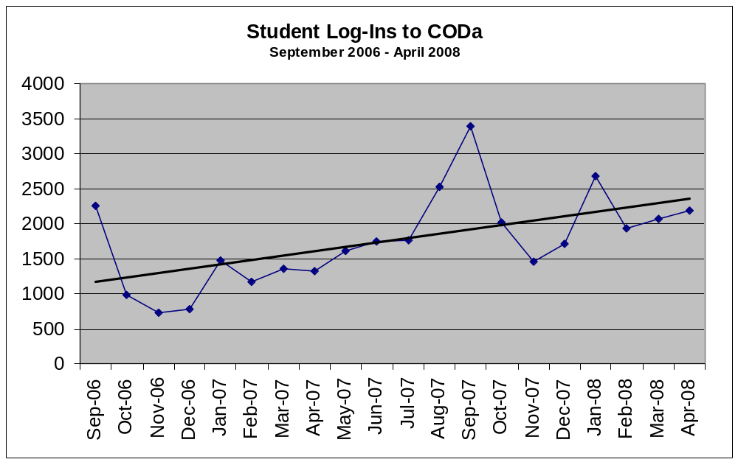
Students show increasing activity using CODa for position searching. We are beginning to have enough data to see patterns in student position search behaviors. Above, significant jumps in log-in numbers reflect increased searching for positions at the beginning of fall (largest increase) and winter quarters.

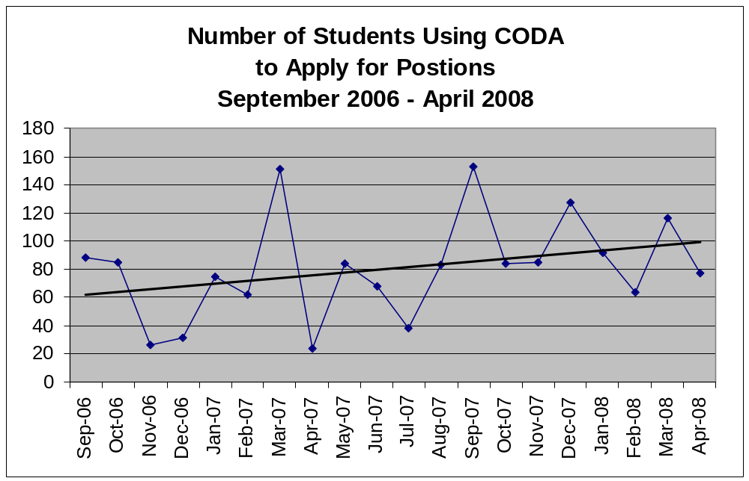

In addition to increased us of the CODa database, we can see a trend in increasing student sophistication in suing the tools that are part of the database. This chart shows that students are increasingly using CODa tools to apply for jobs on-line.
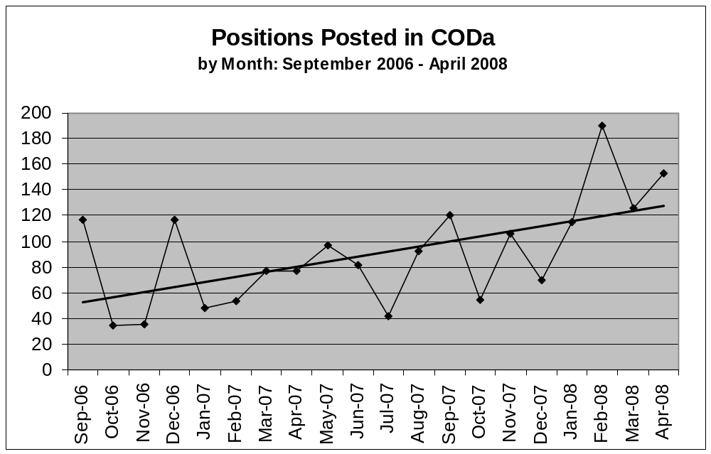

This chart shows the trend in posting of new positions by on- and off-campus employers from the go-live date of CODa through April 2008 (not including the data moved from the old database of positions to CODa).

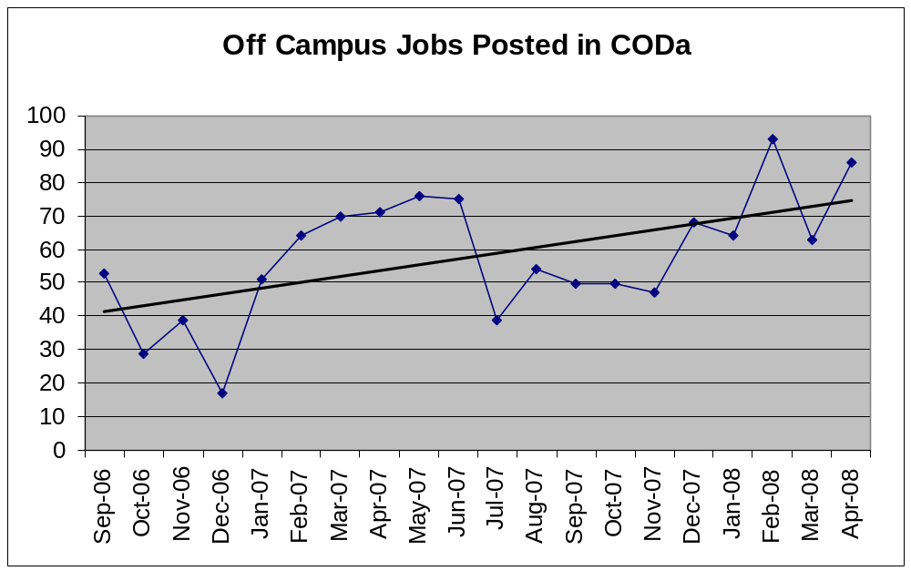

This information reflects in increase in off-campus positions posted. This increase is largely a result of our work in the SEO on the Job Location and Development program.

Police Services

Police Services Mission Statement

“A partnership based on mutual trust and understanding, between the members of the Evergreen Community and the Department of Police Services, sharing the responsibility of providing a safe learning and working environment through community awareness, involvement and education.”

Professional Policing Philosophy

The Evergreen Police Services (EPS) provides policing services based upon the following professional policing philosophy:

Community Based Policing

The delivery of police services is a community-based activity that reflects a partnership with the campus community that is defined by the following features:

- Students, employees and visitors are involved in the delivery of police services.
- Police employees are active members of the campus community and are involved in campus events and activities.
- Responsiveness to community needs and expectations is a high priority to Evergreen Police Services.
- EPS enjoys strong and visible support from the campus community.
- A strong sense of safety within the community.

Problem Solving Policing:

Police service delivery strategies and tactics are based upon community needs, crime, and quality of life issues.

- EPS actively identifies key problems in the community as the basis for the on-going proactive delivery of police services.
- EPS seeks an understanding of community concerns and what the causes are as the basis for crafting specific strategies and tactics.
- EPS actively seeks partnerships with other campus departments and the community as one means to solving crime and enhancing the quality of life.
- Solving crime and creating these partnerships is an important measure of police effectiveness on The Evergreen State College Campus.

Approach to Policing:

The delivery of police services is based upon a proactive and aggressive approach to serious criminal activity:
- EPS employs a pro-active assertive approach to confronting criminal activity.
- EPS utilizes enforcement and other active tactics to address criminal behavior.
- EPS utilizes a “highly visible presence” approach to patrol and delivery of police services.
- EPS is respectful of individual rights while aggressively working to maintain a safe and secure community.

Preventive Policing:

The delivery of police services is based upon the prevention of crime and mutual understanding.
- Police services, strategies and tactics are designed to anticipate and prevent crime and disorder.
- The delivery of police services is not simply a reaction to crime and/or reported incidents, but is a proactive attempt to prevent and/or decrease incidents on campus property.

Knowledge and Innovation Based Policing:

Delivery of police services is based upon a “best practices” approach and current knowledge available to the police profession.

- The delivery of police services is based upon the existing and expanding knowledge and expertise of the EPS employees.
- EPS actively seeks the latest knowledge and innovations available to the policing profession.
- The delivery of police services will be informed and continuously modified by a “lessons learned” approach to understanding on-going events and critical incidents.

Values Statement

The Evergreen Police Services delivers professional police services based on the following values:

Ethics and Integrity:
- Be honest
- Do the right thing
- Take responsibility
- Be accountable

Leadership:
- Expected from all members of EPS
- Show fairness and impartiality
- Be consistent
- Be trustworthy
- Lead by example
- Use open communication

Respect:
- Each other
- The community
- Diversity

Professionalism and Excellence:
- Team work
- Community partnership
- Dedication and commitment
- Accessible and approachable
- Quality service
- Empathy and caring

Innovation:
- Encourage and implement new ideas

Vision Statement

It is the vision of the Evergreen Police Services to be a recognized leader for excellence and professionalism. This reputation for excellence will be built upon:

- A commitment to a healthy and attractive organizational climate that makes EPS a highly desirable employer.
- An organizational culture that values our employees as it strives for continuous improvement and development.
- A commitment to innovation and “forward looking” policing strategies for the future that reflects trends in community growth and development.
- A new and comprehensive training model that is committed to professional development and professional competence that promotes the overall needs of the police organization.
- A commitment to making The Evergreen State College a great and safe community with a sense of comfort and security, and a consistently low crime rate.

Improvements/Accomplishments:

- Created “Vision, Mission, & Values” Pamphlet
- Created Police Services Brochure
✓ Survey on police services was completed and sent out via campus e-mail and
community mail out
- Increase staff meetings
- Police Officers
- Dispatchers
- Parking staff
- Additional meetings planned to discuss and address performance standards
- Chief Sorger is new to position and is implementing suggestions made as a result of the WRICOPS assessment, to include increased contact with EPS staff and campus community
- Created and developed a “Recognition” Board to acknowledge positive behaviors. Steps have also been taken by the Chief to address inappropriate behaviors as they occur to include an updated Standard Operating Procedures (SOP) manual which addresses these issues as well
- The overtime budget has been brought under control and efforts are ongoing to better manage staff time
- Training issues have been addressed
- EPS has complied with Criminal Justice Training Commission (CJTC) requirements of 24 hours of training per officer in 2006/2007
- An officer (Lana Brewster) has been assigned to track and schedule training needs
- Community Oriented Policing (COP) – see efforts in the “Community Policing” attachment, which the Crime Prevention Officer is involved in
- EPS web page has been enhanced to better connect our services to the community, and includes statistics and services provided
- EPS is planning a student/staff/faculty academy for academic year 2008/2009 and it is anticipated that this academy will better explain rules of law enforcement on campus to include:
✓ Arming issues
✓ Use of force
- Criminal justice standards
- New EPS Director, who spend 35 years in a local law enforcement agency, and because of his contacts, has re-established relations with local law enforcement agencies
- One example is a formal mutual aid agreement with the Thurston County Sheriff’s Office, as well as the Olympia, Lacey, and Tumwater Police Departments
- Developed “Active Shooter/Armed Intruder” Procedures
- Developed campus notification system

Community Outreach:

- Campus alerts/flyers are ongoing
- Identity theft
- Free child car seat safety checks
- Burglary alerts of campus housing
- EPS has enhanced our lobby by placing a brochure display holder with various resources available to the campus community
- EPS has enhanced our student Crime Watch program, which works from 9PM to 6AM, 7 days a week, and have expanded their duties to include all buildings and parking lots
- Officers have been participating with housing on special events such as the “Midnight Breakfast”
- EPS involved with Freshman Orientation
- Cop Talk – see attachment on previous “Cop Talk” topics
- Officer April Meyers is working with a faculty member regarding a class on “Police Etiquette and Protocol”
- EPS participates in Super Saturday by hosting a informational booth
- Regularly attend Student Union meetings and events
- Involved with Truth & Reconciliation student group
- Offer student ride-alongs
- Attend case management committee group that identifies serious student issues
- EPS web page enhancement
- Participate in crisis intervention training
- Continually reviewing police officer performance standards
- Partnering with the student group “Clean Energy Committee”, who have authorized the purchase of several energy efficient vehicles for Police & Parking Services’ use

Residential and Dining Services

Residential and Dining Services – Mission Statement
In 2006 the department worked together to come up with a new mission statement. Our statement is to work together to be:
A Purposeful community where students, staff, and faculty share a passion for learning and collaborate to enhance student growth. A Just community where the individual is honored, our interdependence is acknowledged, diversity is pursued, freedom of expression is protected and civility is affirmed. A Sustainable community that values, cultivates and maintains its human, natural and physical resources.

Accomplishment, Challenges and Goals
Below is a list of departmental accomplishments, challenges, and goals. It is evident that in the last 10 years much as been accomplished and the department has been growing and changing.

In the last few years as occupancy has been steady and the financial health of the department has improved. As the department continues its deferred maintenance goals, upgrades of current facilities will continue and we hope to see increased occupancy and satisfaction from our student population.

Residential and Dining Services:
Accomplishments
- Hired new Director – 2004, 2007
- Established operational benchmarks for reserves and deferred projects - 2004
- Develop 10 Year Financial Plan - 2005
- Refinanced bonds creating $6M in capital funds - 2005
- Implemented first two years of a ten year renovation plan
- Reorganized Residential Life creating Coordinator of Residential Life and Resident Director for Programming
- Reorganized Residential Facilities student staff reducing operation expenses
- Assumed management of Food Contract - 2004
- Implemented new meal plan structure - 2004
- Renamed department and created new mission statement – 2006

Challenges
- Continue to explore Freshman and transfer enrollment trends and their effect on occupancy
- Maintain strong financial plan for Residential Services and continue capital investment in facilities
- Develop a financial plan for Dining Services that generates equipment and capital reserves
- Explore meal plans options

Goals
- Strengthen connections with academic and divisional partners
- Participate in conversations regarding a residential based college experience
- Complete design review for new Freshman Halls Courtyard, Administrative Building, ADA space in the Residence Halls and implement plan
- Create a sustainable food operation in the renovated CAB building
- Plan for additional housing in 3-5 years
- Increase marketing efforts for department with emphasis on dining services

Dining Services:
Accomplishments
- Campus wide discussion regarding food options at Evergreen Food Service DTF - 1999-2000
- Selected Bon Appetit new food service provider - 2001
- Implemented mandatory meal plan for students living in the Residence Halls with less than 40 credits - 2002
- Selected Aramark new food service provider - 2004.
- Implemented new gate (block) meal plan featuring “all you care to eat” dining
- Assumed responsibility for the management of Food Service contract - 2004
- Establish Strategic Food Service Committee -2004
- Developed sustainable benchmarking for local and organic purchasing
- Eliminated $500K debt from Bon Appetit contract period
- Created Food Service Committee composed of students, staff and faculty to review food operation bi-monthly - 2004
- Completed $250K kitchen equipment replacement project - 2006
- Implemented financial plan to operate debt free by 2009
- Selected Porter Consulting to make recommendations about meal plan structure for the future renovation- 2007

Challenges
- Initial high turnover of leadership positions in Aramark management
- Continual meal plan development
- CAB remodeling scheduled for 2009-2010
- Create a summer operation which is sustainable

Goals
- Full involvement in the CAB remodel
- Improve enrollment in voluntary meal plans
- Continue to explore a room and board option
- Continue to explore students food preferences
- Explore innovative food delivery methods

Residential Facilities:
Accomplishments
- Initiated apartment style exterior painting project; replaced roofs on four modular units - 1998
- Painted the exteriors of E, F, and H buildings and the HCC; replaced roofs on modular units 303, 307, 315, and 318 -1999
- $800K replacement of all roofs on buildings A, B, C and D with long lasting metal roofs - 1999
- Painted the exteriors of I, J, K, N, and P buildings; provided design and initiated construction of the campus compost facility - 2000
- Painted the exteriors of Q, R, S, T, and U buildings - 2001
- As part of a student-originated project, replaced all phase one lighting with energy efficient model. Initiated replacement of phase two lighting - 2002
- Hired full-time Locksmith/Residential Maintenance Supervisor; restructured nighttime maintenance callback program - 2003
- Removed all kitchens from B-building and converted them into bed spaces. Adding 14 beds and 2 social spaces - 2004
- Removed all kitchens from C-building and converted them into bed spaces. Adding 14 beds and 2 social spaces in - 2004
- Repaired and redesigned modular sewer system. Renovated the Prime Time Advising and summer guest services spaces and created television lounge - 2004
- Replaced primary building entrance doors in A, B, C and D buildings, improving security, accessibility, and energy efficiency - 2005.
- $500K renovation of D building; removed all kitchens converting them into bed spaces. Adding 18 bed spaces and 2 social spaces. Removed asbestos, added sprinkler system, installed laminate wood flooring, installed new lever handle lock sets and replaced all furniture.
- $1M replacement of all roofs on buildings E through U with long lasting 50 year metal roofs. Improved ADA access, completed lighting upgrade. Created 6 new Resident Assistant’s rooms in A building.
- Established a contracted partnership with Western Washington University regarding the use of environmentally preferred cleaning products.

Challenges
- High turnover rate for student employees
- Recruiting talented student employees
- Lack of shop/storage space
- Limited time each year for renovations
- Continue to contain cost and fund reserves and defer projects (Should this read “on deferred projects” or “and defer projects”)

Goals
- $1M renovation of B and C buildings; remove asbestos, add sprinkler system, install new laminate flooring, replace all furniture, install new lever handle lock sets – Summer 2007
- $1.4M renovation of five elevators in A, B, C and D buildings – Summer 2007
- $400K new shop/storage space development – Fall 2007
- Continue with implementation of the facilities portion of the ten-year plan

Residential Information Technology:
Accomplishments
- Installed broadband Internet all buildings except Modular Housing - 1997
- Created ResTech student technology support - 1998
- Increased bandwidth several times in past ten years
- Installed network monitoring tools and procedures - 2002
- Develop appropriate use (copyright) policy
- Moved from home built database system to industry standard (RMS) software - 2002
- Automated assignments, room management, work order tracking, incident reporting, and inventory - 2003
- Moved to web based calendar system for RA duty logs and ResLife duty calendar - 2005
- Instituted off site data backups for disaster recovery
- Created new website, containing application process, contracts and policies - 2006
- Moved manuals to web based documents for RA, ResTech, and Student Facilities over past three years
- Move from paper notice to email notice – 2006
- Provide internet access to Modular residents -2005

Challenges
- Define management/organizational principles for electronic documents (MOPED)
- Maintain and expand network infrastructures
- Define IT responsibility and expectations
- Automate check-in and check-out documents by emailing most information, reduce to a one page signature document
- Planning for future IT initiatives

Goals
- Reduce paper documents as much as possible
- Develop online application with Banner interface.
- Facilitate easy access to statistics and reports for all professional staff
- Increase bandwidth

Residential Life:
Accomplishments
- Implemented Freshman Experience Program in building A - 1999, expanded to building B - 2000, expanded to building C - 2002 and finally to building D - 2006.
- Created Prime Time Advising in A building - 2000
- Implemented the ACUHO-I/EBI Resident Study National Benchmarking Survey Tool and administer annually in late fall quarter - 2003
- Improved RA to resident ratio from 1 to 44 (1998) to 1 to 34 (2006)
- Developed single bed space locations for Apartment Style RA’s living with residents, providing 5 additional beds for residents - 2000
- Established single bed space locations for Freshman Hall RA’s living with residents, providing 15 additional beds for residents - 2006
- Implemented Sustainability and Community Action House Program in Apartment Style Housing - 2005
- Hired Programming Resident Director position - 2005
- Created Coordinator of Residential Life position - 2006
- Edited and refined RA manual - 2001, 2003 and 2005. Moved manual to web - 2006
- Created Living Learning Agreement to facilitate living agreement by RA’s in apartments/units (attach LLA) - 1999
- Instituted two-credit spring RA class entitled Community Leadership with Campus Residents, (attach RA job description/syllabus/passport)
- Improved relationship with Police Services, nightly walkthroughs with RA and Police Officers
- Improved judicial case management with Campus Grievance Office

- Created judicial incident reporting/tracking system http://www.evergreen.edu/housing/office/fulltime.htm

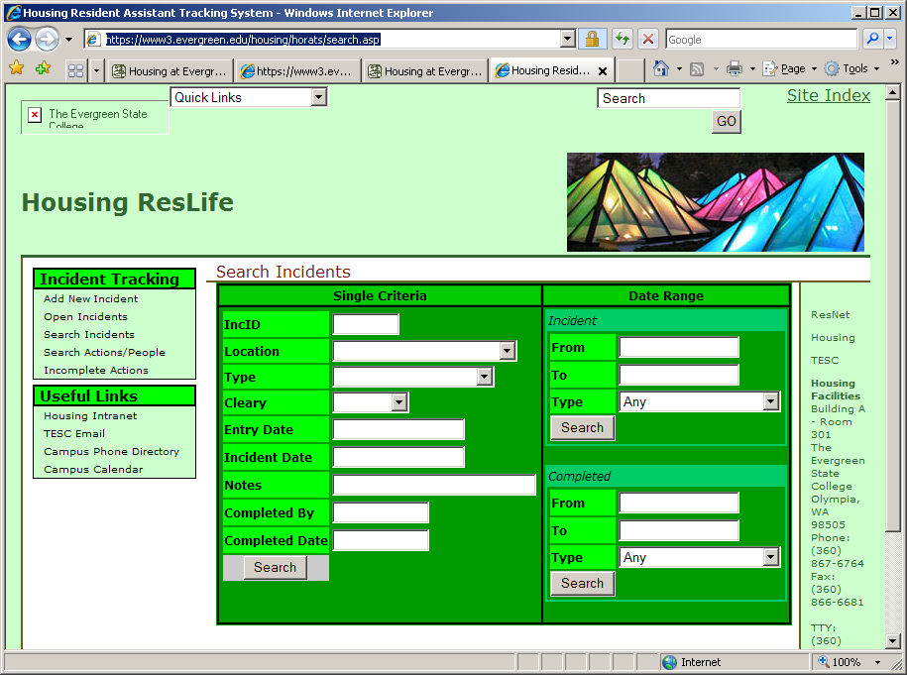

- Revised and reformatted contract, policies and procedures for web access by residents http://www.evergreen.edu/housing/policies/

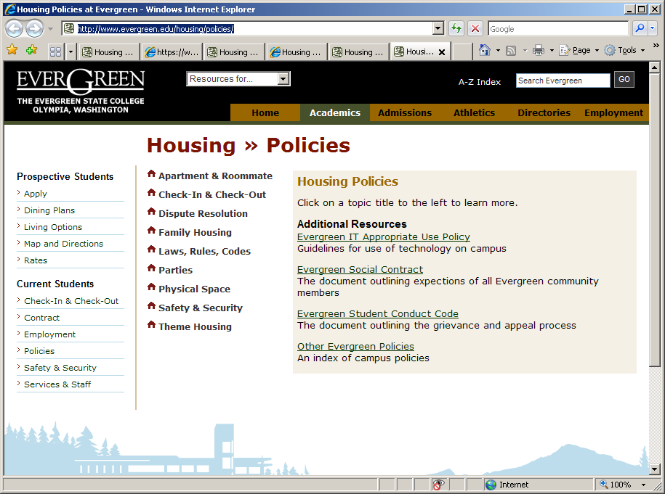
- Improved social space in Freshman Halls (buildings A, B, C and D) adding lounges and new furniture
- Refurbished Housing Community Center creating central social space for resident community - 1998
- Relocated and expanded Prime Time Academic Advising Center - 2005
- Implemented RMS software Incident Reporting (IRs) - 2002
- Improved application process http://www.evergreen.edu/housing/apply/

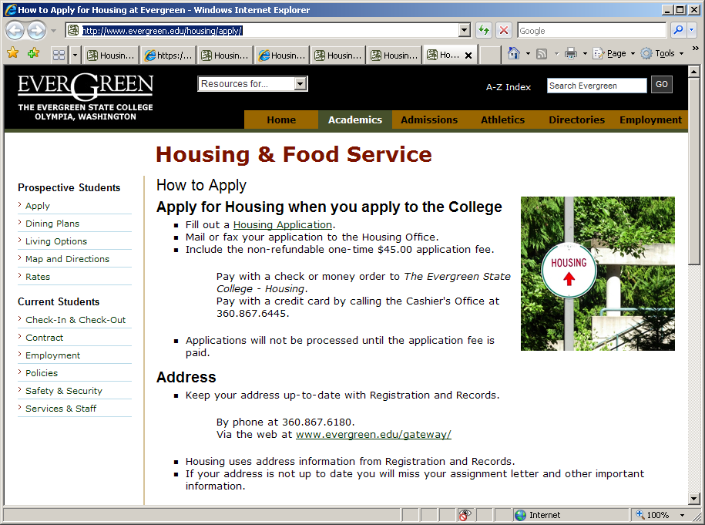

Challenges
- Students living with psychological conditions and the effect on roommates, other residents, RA and professional staff.
- Recruiting qualified student candidates to be RA’s
- Recruiting exceptional RD’s

Goals
- Continue to focus on the residence halls as an educational environment
- Support the Greener Organization in evolving into a full functioning RHA
- Move the ACUHO-I/EBI Resident Study National Benchmarking Survey Tool from paper to web based - Fall 2007.
- Create a comprehensive student assessment plan which integrates current ACUHO-I/EBI data with focus groups data, student exit surveys and retention data.
- Continue to employ the RA’s in creating a healthy social environment for residents through positive policy enforcement and sound programming
- Install RMS judicial software to improve communication with Police Services, Campus Grievance Office, and increase statistical report capabilities
- Improve resident retention from first to second year and from second to third year

Student and Academic Support Services (SASS) – Academic Advising

Academic Advising Mission and Goals – A Current Assessment

The mission statement of Academic Advising at The Evergreen State College is:
Academic Advising promotes Evergreen students’ access to learning and growth. We help students understand the structure of the college and realize the variety of educational options available to them. We collaborate with students in the discovery and exploration of meaningful strategies for learning.

In the past ten years, our broad goals have been:
- Programmatic outreach to first-year students
- Individual outreach to students experiencing unusual difficulties
- Forging links with faculty for advising students
- Creating web-based advising resources for students and faculty advisors
- Enhancing internship partnerships and processes to support students putting theory into practice
- Professional development for all advising staff

For each of these goals, we have devoted considerable attention and experienced many successes.
- Programmatic outreach to first-year students begins formally with Freshman Advising Day in May, a one-day campus event for fall admitted freshmen and their families. All student participants attend an Academic Planning Workshop as part of the day’s activities. Orientation Week, in September, continues our outreach to first-year students, now including transfer students in a mix of academic planning and other activities in which advisors are involved. The Core Connector program, in which each core (all freshmen) and lower division (half freshmen) program has an assigned advisor visiting the program and interacting with the students, is truly the center of our outreach to first-year students. Finally, we continue to provide academic advising in the residence halls via the Prime Time Advising Office, open three evenings per week.
- The Dean of Student Academic and Support Services convenes a group of campus leaders to consult and manage our coordinated responses to students experiencing unusual difficulties. The Director of Academic Advising is a member of that group, and academic advisors are often designated to be the student’s main point of contact, or “case manager.” Additionally, faculty often contact an academic advisor (particularly if there is a core connector) to consult on how to assist a student in a crisis.
- Academic advisors work with faculty in many ways in direct support of their advising of students. Some of these are: Core Connector program, in-program presentations, faculty rotating assignment in academic advising office, study abroad advising for in-program travel, Reservation-Based Tribal Studies advisor liaison, Beginning the Journey team teaching with faculty, academic fairs and advising festivals, faculty teas with advising staff, and the development of web-based advising resources for faculty to use. Additionally, the Director of Academic Advising attends new faculty retreats, ongoing meetings for new faculty, and all faculty summer planning institutes to help clarify and support advising roles for faculty.
- Over the past ten years, all web-based resources have increased, including those created by Academic Advising (www.evergreen.edu/advising). Currently, our web-based advising resources include information for students, for faculty advisors, and for community partners who offer internship opportunities for our students. Updates to our web resources are periodic and frequent. During the registration cycle, some of our information is updated daily.
- Internship partnerships and processes are important to our work with students, and we strongly encourage all students to consider earning internship credits at some point in their study. We have been a partner in the design and implementation of a new web-based system for students to create Internship and Individual Learning Contracts; this tool will go online for Fall 2008. We continue to work with other College units to promote and maintain the CoDA (Community Opportunities Database) for internship providers, and we sponsor an annual “Community Opportunities/Internship Fair” which expands our base of community partners.
- Ongoing professional development for academic advisors is needed in many areas, as this work requires a variety of competencies. Staff in advising have attended professional conferences in areas relating to our work: diversity and anti-oppression learning, advising theory-to-practice, First Year Experience/Students in Transition, and educational reform and renewal, for example. We have for several years had a special series of weekly professional development meetings devoted to enhancing our cultural competencies as we work with our students and with each other.

Goals for the Future

Academic Planning Workshop. One of the outcomes of the work of a recent task force at the College has been to make attendance at an Academic Planning Workshop mandatory for all students who are new to the College. This change creates opportunities for us to examine ways to deliver the workshop content in different ways to different student populations. Transfer students, for example, or high school direct students with significant community college coursework (via Running Start), need some of the same things and some different things as we introduce them to academic planning in the unique environment of Evergreen. Making this workshop appropriate and useful for all students is a current goal. Additionally, we are turning our attention to methods and timing of assessment of the impact of this new requirement on success measures for students (persistence, engagement, credits earned, for example).

Advanced Academic Planning Workshop. We are planning for an expansion of the Academic Planning Workshop, aiming to create a second-level workshop which could be useful to students in the middle of their study here. This could be presented in academic programs and courses, as well as in campus-wide venues.

Advising needs of transfer students. We have received much good information in recent years from our Institutional Research Office about our student population, most notably transfer students. Academic Advising is part of a College-wide effort to look at the ways we can better support the success of transfer students.

Streamlining programs and services for first-year students across the campus. There are a variety of initiatives recommended by our task force on “First Year Experience” in which Academic Advising can be centrally involved. Beginning the Journey, the two-credit course which was begun again in Fall 2007 as a collaboration between Student Services and Academic Affairs, has much potential for expansion, and academic planning content is an area which we are considering carefully. We also would like to create more seamless links between Freshman Advising Day and the later Orientation Week programming, and Academic Advising has much to contribute there.

Supporting increasing involvement of faculty in academic planning with students. Academic Advising is uniquely able to provide support for the College-wide effort to create systematic ways for faculty to assist students with academic planning in the context of their programs and courses. We have created advising resources for faculty already, and these can be enhanced. We can provide training. We can support these efforts with our Core Connector program.

Closer partnership with Career Development and Academic Advising. In an educational environment like Evergreen, where academic planning is inextricably linked with career and life planning, Academic Advising and Career Development have opportunities for collaboration in service to students from the very beginning of their study here. We have a goal to increase our partnership with Career Development and link this to our academic planning work with students.

SASS – Access Services for Students with Disabilities

Access Services for Students with Disabilities: Mission Statement

Access Services is committed to providing a comprehensive and well-coordinated system of auxiliary aids, academic adjustments and other services to qualified students with disabilities. It is our goal to invite and celebrate diversity within our campus community. We utilize a holistic and individualistic approach to assure students with disabilities equal access to the educational opportunities, programs, services and activities available at Evergreen.

Access Services for Students with Disabilities: Goals

- Provide comprehensive services to students with disabilities.
- Work collaboratively to increase awareness of disability and diversity issues and foster partnerships to maximize services to students.
- Increase awareness of resources and services for students with disabilities.
- Provide ongoing staff training and development for current and new professional staff, interns and student support staff.
- Improve access to computers and technology for students with disabilities.
- Reduce timelines for intake and service delivery.
- Provide advocacy and support for an accessible campus.

Access Services for Students with Disabilities: Evidence of Goal Attainment

- Provide comprehensive services to students with disabilities.

- Provide auxiliary aids including sign language interpreters, CART captionists, assistive and adaptive technology, notetakers, FM listening systems, alternate format books.
- Provide academic adjustments including alternate test arrangements, reduced credit load, flexible assignments.

- Work collaboratively to increase awareness of disability and diversity issues and foster partnerships to maximize services to students.

- Implemented Access Services film series to increase awareness of disability issues. Presented quarterly to the greater campus community.
- Present training on Access Services, disability issues, and accommodating students with disabilities to new and returning faculty.
- Developed guidebook on supporting students with disabilities in the classroom as a resource for faculty.
- Develop and present training on disability issues and supporting students with disabilities to Writing Center tutors, First Peoples peer support staff, Residential and Dining Services support staff, and SASS staff.
- Collaborate with TRiO/KEY Student Support Services to support the academic success of students with disabilities.
- Coordinated workshops for staff and faculty on various disability topics including: Supporting College Students with Asperger’s, Supporting Students with Psychiatric Disabilities, Learning Disabilities and ADHD, Disability Rights.

- Increase awareness of resources and services for students with disabilities.

- Developed Access Services website: http://www.evergreen.edu/access/
- Implemented Access Services Orientation Program for new students.
- Utilize student e-mail accounts for quarterly mass mailings of Access Services information and application forms.
- Provide Access Services information at all Academic Fairs.

- Provide ongoing staff training and development for current and new professional staff, interns and student support staff.

- Professional staff attend state and national conferences on disability issues three times per year.
- Maintain professional memberships for AHEAD, NASPA, WAPED (Washington Association on Postsecondary Education and Disability).
- Weekly staff case management meetings; staff meetings; workshops and trainings. Student support staff participate in weekly meetings and attend quarterly student employee trainings.
- Professional staff have recently attended multiple trainings on issues facing injured/disabled returning veterans.

- Improve access to computers and technology for students with disabilities.

- Collaborated with Computing and Library staff to purchase accessible computer stations and software for students with disabilities, using grant monies.
- Established Assistive Technology (AT) Lab. Student interns provide 1:1 training and support in multiple adaptive software applications.
- Coordinated AT Lab open house events to increase campus awareness of accessible computing options.
- Purchased accessible computer stations and software for the Tacoma branch campus computer lab.
- Maintain inventory of accessible equipment and technology available for students to check-out from Media Loan. Equipment includes: CCTV’s, microscope magnification camera, large screen laptop computer, assisted listening systems, digital recorders, audio book players, talking calculator.

- Reduce timelines for intake and service delivery.

- Developed new forms and streamlined process for student intake and faculty letter of accommodation. Reduced timelines for completion of intake to completion of letter from one week to one hour.
- Upgraded system of converting books to alternate format from audio recording of books, to high-speed scanning of books. Reduced timelines for converting print materials from 20 pages per hour to 3 hours per book.

- Provide advocacy and support for an accessible campus.

- Coordinate ADA Compliance Advisory Committee to review and address campus-wide ADA and accessibility issues.
- Coordinated workshop presentation on the ADA and compliance standards for staff and faculty.

SASS – Career Development Center

Career Development Center Mission Statement

The mission of the Career Development Center is to provide consistent, quality Career and life work planning for students and alumni of the college. Embracing the value of a liberal arts education, the Center connects the learning of students to the content of academic programs and plans and implements services and activities to compliment the curriculum. In programming, the Career Development Center works collaboratively across campus with faculty, staff and students to connect theory and practice. The Career Development Center is closely allied with Academic Advising and intentionally designs programs that address career and academic pathways in the college curriculum.
To assist students with self-knowledge; academic direction; employment; graduate school; community service; and life work planning, the Center provides individual career counseling; workshops; resources; referral; programs; Career Fair; Graduate School Fair, coursework; clinics; and technological access. Professional staff provide specialized career counseling to students preparing for graduate study, working with the offices of the Veteran’s Administration, Labor and Industries, the Department of Vocational Rehabilitation, graduate programs and the Evening and Weekend Studies Program.
Students receive assistance and support with assessment including: Transcript Review, Myers-Briggs Type Indicator (MBTI), Campbell Interest and Skill Survey (CISS), Self Directed Search (SDS), John Holland’s (RIASEC) and the Washington Occupational Information System (WOIS). Students receive support with occupational research utilizing a 7,000 volume Career Resource Library and a 300 file website at www.evergreen.edu/career/. Workshops and individual sessions provide help with orientation, resume writing, job search strategy, interviewing skills, mock interviewing, portfolio development, graduate school advising, GRE/LAST/MCAT practice testing, networking, transition, job keeping and job coping, and re-careering.
Current students access career mentors through the Alumni Career Educator (ACE) files providing opportunities for current students to get advice on occupations, employment, travel and study abroad and graduate school from Evergreen Alumni. The conversion from BlackBaud Raiser’s Edge software to BANNER was accomplished with a partnership between the Alumni Office, the Office of College Advancement and the Career Development Center. The transition of the database has provided greater opportunity for access to students and an increase in alumni participation in the ACE program.
The Career Development Center has worked closely with faculty to plan and present a number of workshops and trainings within nine (9) academic programs assisting students with academic and career pathways in the life sciences, environmental science, computer science, performing arts, language arts and social science.
This recent academic year the Center participated in the Curriculum Visions DTF envisioning long term curriculum planning. Staff are partnering with Academic Advising and faculty to teach the freshman advising program, Beginning The Journey. A hallmark partnership is the recent collaboration between the science faculty and the Career Development Center. For the past two years a Career Counseling Specialist has provided specific career and academic advising for the National Science Foundation (NSF) Computer Science Engineering and Math Scholarship (CSEM) students. This year the Director of the Career Development Center is serving as assistant project director for the four year NSF Science Technology Engineering and Math (STEMS) scholarship grant.
The new Student Athlete program partners the Career Development Center, the Athletic Department, Academic Advising and faculty to insure our student athletes receive ongoing career and life work planning and advising. This fledgling program is staffed by the Career Development Facilitator who also serves the college as the Women’s Assistant Women’s Basketball coach.

Career Development Center: Goals

- Increase student access to career development resources.
- Provide staff training and development for current and new professional staff, student staff and interns.
- Work collaboratively across campus to provide increased visibility and service delivery.

Career Development Center: History

Originally the Career Development Center was housed with the Office of Admissions and the Financial Aid Office. Members of the faculty often contacted graduate schools in person or in writing to discuss the curriculum and narrative evaluations, informing colleges and universities of our mission and foci. In 1987 the college chose to co-locate all of the student affairs offices in one location to simplify the student’s process for accessing services. At that time the Career Development Center was housed with Academic Advising, the TRIO programs, Cooperative Education and Internships, and First Peoples’ Advising Services on the first floor of the Library Building. Student Services was re-organized and the newly minted Student and Academic Support Services continued to focus on “one stop shopping” for students. A new location placed the Center on the second floor of the Library adjacent to the Academic Deans. Currently, the Career Development Center is co-located with Academic Advising, Access Services for Student’s with Disabilities, First Peoples’ Advising Services, GEAR UP, KEY Student Services, and Upward Bound in temporary housing until the Library renovation returns us to Library 2153.

Career Development Center: Evidence of Achievement

- Initial Staff Training Checklist; Quarterly Staff Training Retreats; Weekly Staff Case Management Meetings; Conferences; Professional Membership; Weekly Staff Meetings; Workshops and Trainings.
- Developed 24/7 website http://www.evergren.edu/career/
- Director and Career Counseling Specialist serve on the Evening and Weekend Coordinating Committee. Adjusted location and drop in hours to accommodate Evening and Weekend College schedule.
- Renovated and reorganized the Career Resource Library.
- Reorganized and updated the Alumni Career Educator (ACE) files
- Reevaluated and reorganized job postings and distribution.
- Increased workshops in academic programs; Residence Halls; Evening and Weekend Studies; NSF Grants.

SASS – Health and Counseling Center

Health and Counseling Center Mission and Goals

The provision of Health and Counseling services within an institution of Higher Education offers the opportunity to emphasize education in addition to providing clinical services. The focus on education within our unit extends the interaction with patients beyond clinical care and general health education to the level of educating students about how to access the healthcare system, use resources appropriately and become effective self-advocates as they access care on campus and in the community. The Health Center offers a unique Student Medical Assistant Program, a part-time course which typically attracts students who are interested in the possibility of a career in the health care field. The Counseling Center has a Graduate Intern Program, designed for Master’s level and Ph.D. candidate graduate students seeking a practicum.
Both of these programs support the larger institutional values of linking theory to practice.

Highlights of Accomplishments
Health and Counseling Services has experienced some significant transformation over the past decade. With one or two exceptions, there has been complete turnover in the Health and Counseling Centers and some modest growth of the FTE for each center. The predominant theme has been meeting the increasing mental health needs of our students.

The challenges of accurately assessing and responding to the issues of depression, anxiety, substance abuse and more serious psychological problems has been the focus of our work and has influenced the design of our services.
Some of the structural elements which have taken place in the unit include:
- Renovation of space to allow for more efficient patient flow.
- The Health Center increased the number of exam and procedure rooms by moving in to space previously occupied by the Counseling Center.
- The Counseling Center moved up two floors from Health Services and essentially doubled the number of counseling offices and added a small meeting room in addition to the group therapy room.
- An addition of one FTE Psychologist position in The Counseling Center
- An addition of one FTE Physician Assistant/Nurse Practitioner in The Health Center.
- The transfer of The Office of Sexual Assault Prevention from Student and Academic Support Services to Health and Counseling Services

This transition has impacted the frequency of informal meetings between Health and Counseling Staff, but the two centers function as one team under one supervisor, providing physical and mental health support for the student body. Referrals are routinely made between the Health and Counseling Centers for medication and counseling. Providers consult regularly to maximize treatment options for students. The larger group which includes the Health Center, The Counseling Center and The Office of Sexual Assault Prevention meets on a regular basis to review services and processes, making necessary alterations to meet the needs of the students.

Both Health and Counseling centers have shifted the way appointments are scheduled to meet the changing needs of students and maximize economy of resources. Some of those changes include:
- Extending Counseling Center Walk-in/Crisis hours through Friday afternoons
- Conducting Initial Consultations to more accurately assess needs of students seeking counseling prior to assigning them to a therapist or putting them on a wait list.
- The addition of an Urgent Slot at the end of the day to accommodate afternoon crises.
- Increased emphasis on groups as an adjunct or alternative to individual counseling.
- The Health Center implemented Same Day Acute Care appointment slots every afternoon for acute illness/injury.
- Psychiatric referrals to the Health Center require intake forms and paperwork prior to scheduling appointment to maximize efficiency of time spent with the provider.

Other significant enhancements have occurred in the area of public and/or community health on campus.
In the wake of global health concerns brought on by SARS, Avian Flu and most recently pandemic flu, the Health Center has broadened its public health role to provide consultation around these issues as well as emergency preparedness in general.

- The Health Center has significantly improved and expanded the immunization program to include better immunization storage and tracking
- The addition of a Travel Medicine Clinic in the Health Center
- Recommendations for senior level administrators around Pandemic and natural disaster planning.
- The development of a Medical Response Plan consistent with Incident Command System structure.

Clinical and/or academic programs in both Health and Counseling Services have been re-structured to provide high quality educational experiences for SMAs and Graduate Interns. The SMA program became a part-time academic program in 2005.

Research

One of the goals for Health and Counseling Services has been to seek out opportunities to participate in research or collaborative projects that could benefit our students. Health and Counseling Services has been involved in a few collaborative research projects. These projects are reported under the “Research” tab in the Self study binder. The first and largest project, MC² addressed the substance use of college students with empiric evaluation of three interventions designed to reduce harm associated with substance use and abuse. Another state-wide collaborative project, The Washington Statewide Assessment (WASTA) looked at the health behaviors of Evergreen students and those in participating colleges and universities across the state, and a third project through the Association of American Colleges and Universities has been the on-going development of a healthy campus initiative.

These efforts have resulted in cross-divisional collaboration, improving partnerships between Student Affairs and Academics as faculty and staff members provide support to the larger student body. This work has provided staff and faculty with training opportunities to make more effective interventions and referrals while working with individual or specific groups of students. A central piece of this work has been through the faculty development Summer Institutes, where Health and Counseling Services clinicians have provided an overview of mental health issues and trends nationally, as well as those issues specific to our campus. Through workshops and small group discussions, the clinicians along with faculty are able to discuss appropriate response to specific issues with the goal of making more effective interventions and referral of students who are of concern.

Challenges

Health and Counseling Services are funded through a Student Health Fee (currently $44 per quarter). This fee is intended to cover the cost of staff time, goods and services needed to provide health and mental health care on campus. The current fee is insufficient to provide the current level of service and the unit has been compensating with a diminishing reserve base. The increase in student body has brought an increase in severity of psychological problems and requests for counseling. This has impacted not only the Counseling Center, but The Health Center as students seek to transfer their medication management or get a new prescription. A number of our students are either un-insured or under-insured which can make referrals to the community difficult. This is further compounded by the limited number of available psychiatrists in the community, which creates few options even for the insured. The demand for service with such limited options poses a real challenge in balancing the needs of the students and what is available on campus with the rising cost of tuition.
The response thus far has been to clearly define the scope of campus based services, referring to community providers when the request exceeds the scope or capacity of our services. This has been a necessary and gradual shift from providing more broad-based primary care for students. In the last two years medical and mental health providers have taken a more active role in helping students get connected with insurance and/or community providers. In many cases this means multiple phone calls to service or insurance providers and subsequent follow up with the student. The emphasis on coordination of care has added a dimension of case management to the provision of clinical care and education for our students.

The demand for services, particularly mental health services comes not only from students and parents, but staff and faculty across campus. Future goals include increasing the number of providers in both the Health and Counseling Center. However, further analysis of the role and expectation for health and mental health service provision on this campus could inform future budget requests and planning for Health and Counseling Services.

SASS – First Peoples’ Advising

First Peoples’ Advising Mission Statement:

To assist students of color in achieving their academic and personal goals through comprehensive academic, financial and personal advising, referral services to campus and community resources and ongoing advocacy within the college. Our services are designed to meet the needs of students of color, and are open to all students.

Goals:

- To improve our presence within the Evergreen community and to prospective students by continuing to develop and implement initiatives to increase awareness of First Peoples’ Advising Services through mailing series, email campaigns, campus events and recruiting visits.
- Work collaboratively within the college community to plan and implement programs regarding all aspects of ethnic diversity.
- Provide advocacy and support for all students
- Increase the effectiveness of First Peoples’ Advising Services professional staff and peer student advisors through staff development and training
- To persist in planning and implementing campus wide programs, workshops and activities regarding diversity issues which reflect the five foci at Evergreen: interdisciplinary study, collaborative learning, personal engagement, learning across significant differences and linking theory to practice.

Evidence:

1. Evidence for Goal Number 1:
-Partnerships with Admissions to welcome each new student of color to campus through mailings, emails and welcome receptions during our new student advising day

-Partnerships with community organizations such as the Latino Youth Summit, Tumwater High School, Gateways for Incarcerated Youth, and the Familias Unidas Education conference

-Partnerships with Reservation-based programs

-Assist with recruitment at community college multicultural college fairs

-Assist Admissions office with on campus presentations to prospective students

-Advise prospective students as needed

2. Evidence for Goal Number 2:
-Beginning the Journey Orientation Program for first year students

-New Student Orientation workshops and activities

-Act as core connectors with Core programs

-Provide advising and workshops at Primetime Advising on a weekly basis

-Provide various workshops, consultations and class presentations regarding: Diversity, Time management, Conflict resolution, Critical Moments, Financial Aid and Scholarships, Writing Skills, Resume Writing, Working with Multicultural Populations

-Sponsoring Individual Learning Contracts and Internships

-A member of our staff provided a two-credit option this year called Dialogues on Race and Community with a member of the faculty for Fall, Winter and Spring quarters

-Serve on various campus advisory boards and committees for example our staff participates in the Diversity Planning Institutes.

3. Evidence for Goal Number 3:
-Orientation Programs:
Scholars program: (past 11 years) A program designed to allow new first year students of color, freshmen and transfer, to become familiar with the Evergreen community before orientation week begins in fall quarter. Students are given the opportunity to become acquainted with campus resources, learn the importance of seminar and the importance of participating in various activities on and off campus.

Washington Achievers Program:
These students have been selected by the College Success Foundation, funded by the Bill and Melinda Gates Foundation, to receive financial support to attend college. We mentor, support and guide their educational experience while they attend Evergreen. We set up quarterly group meetings and activities, and meet with each student individually each month for freshmen and sophomores, and quarterly for juniors and seniors. These students have recently been added to our Scholars program.

-Drop-in and regular appt. consultations

-Provide Community building events and activities such as: Community potlucks, Beach Coast Trip, Corn Maze Explorations, Spring Lu’au’s, Cultural Dinners, Free cultural films and teach-ins, Identity workshops, museum and art gallery trips to see the work of artists of color

-Work as needed to support students in need of advocacy during crisis

-Regular contact with all students of color through e-mail and event support

-We provide assistance to all of the students of color groups on campus. Whether they need assistance or co-sponsorship with their events or just need some help with meeting facilitation we provide them with any help needed.

- Evidence for Goal number 4:
-We provide ongoing leadership and communication training for our student staff and professional staff regularly attends diversity training on and off campus

- Evidence for Goal number 5: Campus wide programs:

Diversity Quotes and Community Education Project
This project enhances the hospitable tone of our campus through educational and inspirational materials that we post on a weekly basis throughout the campus. Thematic informational materials and quotes by leaders of color educate the campus community through positive messages about diversity, for example, “What is Kwanzaa?” or, “Why is Dia de los Muertos celebrated?” and, “What is the history behind the Juneteenth celebration?”

Day of Absence and Day of Presence
These events are created to bring awareness and increase critical thinking through programs, workshops and activities regarding diversity, equity, gender and race. On the Day of Absence, students, staff and faculty of color are invited to an
off-campus community-building retreat. On-campus events such as ally-building workshops take place on campus. The Day of Presence represents the reuniting of our community and consists of campus-wide workshops, seminars and activities.

Students of Color Conference
We act as non-voting members of the Multicultural Students Services Directors Council which holds a three day conference each spring that allows students from Washington State Colleges to participate in workshops and activities designed to motivate, share and celebrate their college experiences. Although the event is primarily created for community colleges, Evergreen receives an invitation each year to participate. Each year, through funding from our Students and Activities Board, 10-20 students are selected to attend the conference.

Power of One Conference
This two-day conference is sponsored and hosted by the South Puget Sound Community College. It is directed to Washington State College students and college offices that work with Lesbian, Gay, Bisexual and Transgender student populations. Evergreen’s student organizations such as Queer People of Color, Evergreen Queer Alliance and Women of Color Coalition, to name a few, have participated in this conference with funding assistance from Evergreen’s Student and Activities Board. Through programs, workshops and activities, these Evergreen students are able to network and learn from a variety of speakers and presenters about college experiences and expectations beyond college.

First Peoples’ Graduation
At the end of each academic school year, the First Peoples’ Graduation Celebration is planned to recognize and celebrate the success of our students of color who are graduating. We also include and recognize the success of our graduating Washington Achievers students. The event consists of a program for students and their families that includes student, faculty and staff speakers, performances and acknowledgements and displays of student academic achievements during their years here at Evergreen.

Study Crew/Prime Time
Wednesday evenings from 6:00 pm – 9:00 pm, the First Peoples’ Unity Lounge remains open to allow students a place to check-in with a professional staff member and/or seek the advice from our Peer Advisors or just come by and study. We also inform faculty and staff of this support service to assist students in their academic programs and as a time to offer extended service to our student athletes. We also use this space to hold various workshops and activities.

Chili Wednesdays
This is simply an opportunity for students, staff and faculty to come together in the First Peoples’ Unity Lounge and have a bowl of chili or soup every Wednesday from 12:00 noon – 1:00 pm. It’s a chance to enjoy each other’s company, meet new community members and find out more about Evergreen and resources that are available to everyone.

Critical Moments presentations
For over eight years a team consisting of trained Evergreen staff and faculty has presented workshops to bring awareness and understanding to issues of diversity through critical thinking and dialogue. The heart of the project is the use of case studies involving critical moments in students’ lives to facilitate dialogue about specific student issues. The Critical Moments Project was originally funded by a grant from the William and Flora Hewlett Foundation in the year 2000. The team is currently sponsored through our office and we have recently added Playback Theatre options to enhance the workshops we have been presenting. We have presented in academic classrooms, at conferences and during orientation activities and to new faculty and staff to Evergreen.

SASS – Gaining Early Awareness & Readiness for Undergraduate Program (Gear UP)

Purpose
The purpose of the Gaining Early Awareness and Readiness for Undergraduate Programs (GEAR UP) is to support early college preparation and awareness activities in order to increase the number of disadvantaged students who are prepared to enter and succeed in postsecondary education.

Program Description
This discretionary federally funded six year grant program is designed to:
- Work with students beginning in the middle schools to support early college preparation and awareness through various academic, career and culturally woven events and activities
- Serve an entire cohort of students and follow them as they move through high school
- “Wrap its arms around the students” through a network of support comprised of colleges, schools, parents, businesses, and the community to empower student success in college.

Objectives
1. Increase teachers’ abilities to convey and increase students’ academic achievement in mathematics, reading and writing.
2. Provide pre-college academic counseling and advising.
3. Increase parent, family, community partner and mentor support.
4. Provide comprehensive academic support.
5. Increase student and parent knowledge of and positive expectations about college attendance.
6. Ensure community/school partnerships are effective and sustainable throughout the life of the project.
7. Provide financial education to increase student’s ability to pay for college.
8. Increase cooperation between the Oakville School District and the Confederated Tribes of the Chehalis to prevent Native American Student dropout.

Evidence of Accomplishments
Assessments
a. Annual Performance Reports 2007-2008
b. Northwest Regional Educational Laboratory Report 2007-2008

ANNUAL PERFORMANCE REPORT 2007-2008

SECTION I: EXECUTIVE SUMMARY

Project description. The Evergreen State College Partnership Project worked with three cohorts of students at two middle schools, two high schools, and one combined middle/high school: Lochburn Middle School, Woodbrook Middle School, Clover Park High School, Lakes High School (all Clover Park School District) and Oakville Middle/High School (Oakville School District). In addition, nine community partners contributed to our work. The project has eight objectives:
- Increase teachers’ abilities to effectively convey mathematics, reading and writing subject matter to low-income students and to increase student’s academic achievement especially in the areas of mathematics, reading and writing.
- Provide effective-pre-college academic counseling and advising for GEAR UP students on the development of an academic plan that assures enrollment in college preparatory courses.
- Increase parent, family, community partner and mentor support for the education of GEAR UP students.
- Provide comprehensive academic support for GEAR UP students.
- Increase student and parent knowledge of and expectations of college attendance.
- Ensure that community/school partnerships are effective throughout the life of the project and remain effective after federal funding lapses.
- Increase GEAR UP students’ ability to pay for college.
- Increase the level of cooperation between the Oakville School District and the Confederated Tribes of the Chehalis to prevent Native American Student dropout.

Student description. From April 2007 through February 2008, the project served 2,784 students. This is the fourth year that we are absorbing a considerable number of ninth grade students in the Clover Park School District from two additional feeder middle schools. Approximately half of our students are White; the others are African American (23.3%), Hispanic (13.3%), Asian (10.4%), Native American (2.9%), and Pacific Islander (1.7%).

Major outcomes. NWREL revised study design for comparing cohort students of this reporting year to those of 2003-2004 concluded that GEAR UP students’ knowledge and aspirations towards continuing education beyond high school was high (90%), a slight gain from the 2003-2004 survey. Most parents (90%) reported they often discussed postsecondary options with their children and believed they would go on to pursue a college education after high school. Furthermore, knowledge regarding college by students was increased from baseline year 2003 making it easier for them to navigate college system and make informed decisions. Teachers who also responded to the survey (100%) felt that GEAR UP paved a path for making college planning and preparation more visible and accessible; a 16 percentage point increase from the 2005-2006 response. More importantly, 92 percent confirmed that GEAR UP has postured the college experience so positively that students are significantly more interested now in attending after high school. Similarly, three quarters of the students (74%) agreed that GEAR UP’s impact on them has made them think more about going to college. In short, we were able to demonstrate that there is a positive relationship between the length of time GEAR UP’s presence has been in the schools and the significant impact it has made on student outcomes with regard to college awareness, college knowledge, and college planning and preparation for attending college after high school.

Washington State administers the Washington Assessment of Student Learning (WASL) in the spring of each academic year to students in grades 4, 8, and 10 for reading, math, and writing. Students in grade 10 also take a science WASL. Students meeting the WASL standard increased every year since 2002-2003 in all subjects with an overall higher percent meeting standards, although the trend this year we slid slightly in reading and math, yet gained momentum in writing and remained relatively flat in science. GEAR UP has been involved directly with the cohort represented by the 2006-2007 data—those students performed dramatically well on the WASL. In our cohort, most students met or surpassed the standards in reading (72%), math (30.6%) writing (77%), and science (18%). Still, there is work to be done. Although the trend is positive, the percentages are less than the state averages: reading (80.8%), math (50.4%), writing (83.9%), and science (36.4%).

Because we were able to receive funding for the sixth year of our grant, which would be the final year, GEAR UP staff decided to target our efforts to improve student and family knowledge about postsecondary preparation and financing on the oldest students in our cohort, our seniors, as well as strengthen parent engagement and involvement through developing more cohesive parent resource groups among all partner high schools. We decided that our focus was ensuring our senior cohort was knowledgeable about college and career preparation, and what activities and events and learning experiences these students would need to feel they had the tools necessary to navigate successfully into college. We administered the student and parents’ survey to assess their current level of knowledge and experience during this project’s reporting cycle. The data enabled us to assess the effectiveness of interventions initiated by GEAR UP (e.g., College Recruitment Fridays, FAFSA Completion Nights, fee-paid administration of the ACT) and by the school (e.g., advisory curriculum) throughout the year. To date, 275 (62%) of the seniors completed the biennial survey, approximately 871 seniors attended the College Recruitment Fridays and FAFSA Completion Nights, and 184 seniors took the ACT in February 2008.

Major Successes. We’ll highlight four successes:

Institutionalization of middle to high school transition program. We succeeded in convening Clover Park School District stakeholders to discuss middle to high school transition at a district retreat in spring 2006. As a result of the issues raised at the retreat, the superintendent inserted transition into her district work plan and established a Transition Task Force in fall 2006. These outcomes increase the likelihood that GEAR UP’s focus on middle to high school transition will be sustained. Last year and this year we have worked closely with the peer mentor program at Lakes and Oakville High Schools to integrate principles of a College Student Leader program that GEAR UP established earlier in the project. We are trying to sustain an innovative program by attaching it to one that has already been institutionalized. By teaching peer mentors about college knowledge, and giving them opportunities to develop their own action agendas, we increase the potential for reaching more students with concrete information about college preparation

After school tutoring (CPAs). This year we advanced our after school tutoring in partnership with Centro Latino to provide support on a regular basis for our large Latino student population requiring tutor assistance. We developed a Saturday School to assist through funding and tutors (College Program Assistants [CPAs]), whereby students who require credit retrieval receive the necessary services, which have been shown to positively impact graduation rates, state assessments, D/F lists, and truancies. We succeeded in convening tutors along with Pierce College to provide adult English courses. Parents would also have access to instruction on technology and research to support all programs initiated. The outcomes from these programming efforts have increased the likelihood that GEAR UP’s focus on after school tutoring assistance will be sustained.

Engaging parents systemically. We dramatically increased the number of parents who are engaged and actively involved in their students’ preparation for college as well as becoming a voice in the community networking through the collaborative efforts of Oakville and Lakes High Schools’ Parent College Resource Group. The Parents Resource Group has become an icon for encouraging other school parents and staff to get involved, and are now taking ownership of various events/activities that positively impact students’ high school graduation rates and being prepared and successful in college. As perceived as another critical college resource, both staff and parents at Oakville and Lakes High Schools will likely want to sustain in order to provide continued support for their students’ college goals and aspirations.

Partnership development model. Our aim since the inception of this grant has been to strengthen campus-community partnerships that serve to advance the priorities within the communities we served while deepening the skills, civic knowledge, and values of our students that are so largely overlooked due to district budget shortage, individual time constraints, military mobility, cultural tensions, and poverty. It was our hope from the very beginning that we could derive mutual benefits, extend knowledge, resources and glean expertise from each other in order to meet the needs of our students set among two school districts, one urban and one rural. We deliberated with regard to these rich complexities on how to strategically align ourselves in a way that would best capture what services the communities were promoting that were aligned to our initiatives for transforming the infrastructure and culture of the schools to a mindset that would model “college ready,” “college worthy” students while preparing them for entering and transitioning into college. We deliberately chose community partners whose mission and vision with regard to understanding the value of students’ potential and how critical it was for us to harness and mold their way of thinking while it was open to endless possibilities. Our concept in the beginning and still is proactive and transformative, which in hindsight has deepened our ways of knowing from which to build and strengthen more collaborative and reciprocal relationships within the community for future sustainability.

What has emerged from these partnership opportunities within the community at large is the knowledge that we must maintain an open line of communication and collaboration from which to nourish and replenish our resources. It is imperative that we continue to encourage the evolution of reciprocity and assessment of that exchange to ensure that we are providing the best practices for our students and that our instructors are receiving the training necessary for delivering those cutting edge academic curriculums, especially surrounding reading, math, and science. It is our hope, that if funded for a new grant, we will be allowed the opportunity to work among the thirty two community organizations we have partnered with to such a degree that we will be among those who will “wrap our arms around the students of Lakewood and Oakville” to where students’ lives will be forever changed in ways that will allow them to soar to new heights.

Concerns. Finding ways to continue serving students at all three partner schools, Clover Park and Lakes High Schools, and Oakville High School, with tutors through our College Program Assistants (CPAs) who provide not only daily in-class tutoring and mentoring in science, reading and math, but also after-school tutoring for the Saturday Credit Retrieval School in partnership with Centro Latino, and for the ESL courses being provided in partnership with Pierce College. This continues to be one of our biggest challenges. The uncertainty of receiving refunding for our recent GEAR UP Grant Proposal submission for the upcoming fall 2008 is also unsettling.

NORTHWEST REGIONAL EDUCAITONAL LABORATORY ANNUAL REPORT 2007-2008

EXECUTIVE SUMMARY

Background Description

In September 2007, the U.S. Department of Education awarded The Evergreen State College (TESC) an extension of a previously funded, five-year grant—Gaining Early Awareness and Readiness for Undergraduate Programs (GEAR UP)—designed to increase the number of middle school students who go on to college. The Northwest Regional Educational Laboratory (NWREL) was contracted to continue their evaluation of this program.

During this reporting period, GEAR UP staff members worked with students, parents, and teachers from three Washington schools, as well as with their partner organizations. The schools were chosen to participate because of the large percentage of students on free or reduced-price lunch, mobility resulting from military deployment, and the high percentage of students not meeting standards.

GEAR UP served a total of 2,784 10th-, 11th-, and 12th-grade students from Clover Park, Lakes, and Oakville High Schools in 2007–2008. Students in these three grade levels represented cohort groups that have been followed from the initial GEAR UP grant in 2002 through the sixth-year funded extension of the project in 2007.

Project Activities

In 2007–2008, GEAR UP was a visible presence in the schools and communities where it was implemented. Almost all students and teachers were aware of, and had participated in, GEAR UP services and activities. The majority of surveyed parents were also aware of GEAR UP, although they often did not know the details and had lower levels of participation.

GEAR UP offered a wide array of activities for students, teachers, and parents in 2007–2008. These activities were carefully tracked by GEAR UP Educational Specialists in a database created with NWREL evaluators. Highlights of these activities included:

Students. The majority of GEAR UP students received college counseling and/or academic planning assistance through GEAR UP, with an intense focus on helping seniors prepare for graduation and the complex process of navigating the college application process. Each school was assigned an Educational Specialist who was responsible to organize and implement a great number of college preparation activities. Students engaged in such activities as career and college fairs, weekly college-knowledge sessions, interest and career assessments, college visits and workshops, and college planning meetings with parents and GEAR UP staff members. In addition, College Preparation Assistants (CPAs) offered many students with tutoring, homework assistance, and/or academic enrichment. Other student activities included middle school to high school transition events, educational and cultural field trips, and student-led conferences.

Parents. GEAR UP and high school staff members pushed hard to increase parental involvement through such activities as student-led conferences and one-on-one planning sessions with seniors and their families. Parent engagement was perceived as being higher than at anytime during the previous five-years of GEAR UP implementation. The school district also increased its efforts to involve the community through a comprehensive GATES initiative linked to the GEAR UP work.

Teachers. GEAR UP resources were also directed at teachers. In 2007–2008, schools continued to have significant control of what, when, and how to use their GEAR UP professional development funds. However, professional development became a more district-level priority, to insure greater consistency across schools. Schools used their funding to focus on building-level goals such as advisory programs designed to personalize student experiences and to create opportunities to implement college-going knowledge activities. The district also received funding to extend their Transition Task Force initiative that was seeded with GEAR UP resources.

GEAR UP staff members. Educational Specialists and other GEAR UP staff members worked together to plan and provide the activities and services described above. They worked with students individually and in groups, taught leadership classes, actively participated in bi-yearly planning and reflection workshops with project partners, attended GEAR UP conferences, and engaged in weekly meetings to plan, assess, and reflect on their progress. Their work was not without challenge. The current project year saw changes that required extra support from Education Specialists to help facilitate a smooth transition for the project as it underwent changes in administrative staff, including a new project director and project coordinator who were hired in October and June 2007, respectively.
Outcomes

Knowledge of and aspirations towards college. GEAR UP students continued to have high aspirations for continuing education beyond high school; 90 percent of students believed that they would pursue education beyond high school—a slight gain from the 2003–2004 survey. Most parents (90%) also believed that their children would pursue education beyond high school, and reported that they often discussed post-secondary options with their children.

Student knowledge about college increased from the 2003 baseline year, as shown by an increase in the percentage of students familiar with college terms such as “undergraduate” and “tuition.” However, the majority of students still had difficulty with the correct answers. High school juniors attended college-knowledge workshops at The Evergreen State College. Post-visit assessment demonstrated that, overall, students learned valuable information to help them navigate the college application process.

All teachers who responded to a survey (100%) believed that GEAR UP has assisted in making college preparation and planning more visible; this was a 16 percentage point increase from the 2005–2006 response for this question. Similarly, 92 percent believed that GEAR UP reinforced student interest in attending college. Many students also reported, by survey, that they felt GEAR UP’s impact; nearly three-quarters of students (74%) agreed that GEAR UP had made them think more about going to college. These findings were reinforced during site visits.

Academic outcomes. Results from the Washington Assessment of Student Learning (WASL) showed large gains in students meeting WASL proficiency standards, reduced dropout rates, and increased graduation rates. Although no causal relationship can be drawn with these data, it seems safe to say that GEAR UP has had a positive influence on student outcomes. Each cohort of students across the three GEAR UP schools increased their achievement in reading and writing by as much as 20 percentage points from the baseline, a growth much greater than state averages. However, math and science remained challenging content areas for students, as their proficiency levels were as much as 30 percentage points lower than those reported for English and writing.

Students and teachers believed that CPAs had had a positive impact on their classroom experiences. Despite the reduced number of CPAs in the schools this current reporting period, 100 percent of teachers who used them rated them as “very helpful” to “somewhat helpful” in working with students —a 10 percentage point increase over the 2005–2006 survey. Teachers believed CPAs helped students focus on academic tasks, and the overall role of CPAs, and their perceived impact, increased substantially from previous years.
In conclusion, if GEAR UP is funded for another round of contract work with the schools, the following recommendations, emerging from these data, are presented for consideration:
- Improve student understanding of the concepts represented by the college-knowledge items of the biennial survey.
- Disaggregate graduation rates by subgroups in order to clearly identify those most in need of GEAR UP help.
- Continue to help parents understand the purpose and role of the GEAR UP program.

- If funded for a second cohort of GEAR UP students, it would valuable to conduct meetings with the evaluators, GEAR UP staff members, individual school staff members, and district staff members to build a data collection plan that insures that any in-school and district-level existing data collection activities and outcomes that are not already included, are incorporated into the established GEAR UP database.

An ongoing challenge has been the documentation of professional development activities in the schools. The new GEARUP project director should be commended for taking positive steps to address this need through refining the expectations and criteria upon which schools apply for GEAR UP professional development funds and to emphasize the content areas of reading, math and science.

EXHIBITS

GEAR UP 2008 REACCREDITATION NOTEBOOK AND WEBSITE

The GEAR UP Reaccreditation Notebook will be available for viewing in the exhibit’s room.

For additional information outlining the project’s direct services to students and parents, and our more collaborative and reciprocal relationships within the community, you may access the GEAR UP Website at:
www.evergreen.edu/gearup

SASS – International Advising

International Advising: Mission Statement:

Our mission is to assist domestic and international students in achieving their international education goals through academic, immigration, financial and personal advising, and to foster an educational environment that is informed of international and multicultural issues and opportunities.

International Advising: Goals

1. To support and develop new opportunities for international education.

2. To improve awareness of international education opportunities available to
students through academic programs, consortium partnerships, individual
learning contracts, internships, exchange programs, and direct enrollment options.

3. To improve awareness of financial aid and scholarship support available for
international study.

4. To provide quality support for the 350-450 domestic students who ultimately study overseas each year. This represents 8-10% of the overall student body.

5. To provide quality support for admitted international students on our campus.

6. To work collaboratively with the college community to promote, plan and
implement internationalization efforts in light of the five foci at Evergreen:
interdisciplinary study, collaborative learning, personal engagement, learning
across significant differences, and linking theory to practice.

7. To increase the effectiveness of professional staff and student peer advisors
through staff development and training.

8. To promote an awareness of sustainability issues with regard to international
education.

Evidence:

Goal 1: To support and develop new opportunities for international education.

- Expansion of consortium partnerships in accordance with student and faculty interests through regular and trial consortium agreements. We currently have 17 active consortium partnerships offering over 300 locations for study abroad.
- Collaborative support of faculty as they explore new academic programs that incorporate study abroad components.
- In collaboration with the college community, development of a database of overseas contacts and resources useful to students in designing independent study options.
- Support efforts to increase sister college relationships in conjunction with the Home Tuition Program as outlined by the Washington State Legislature.
- Attend Study Washington meetings – an alliance of state colleges, universities and private organizations that promotes Washington as a destination for international student study.

Goal 2: To improve awareness of international education opportunities available
to students through academic programs, consortium partnerships,
individual learning contracts, internships, exchange programs, and direct
enrollment options.

- Conduct 10-12 workshops each quarter to inform the college community of study abroad options and processes.
- Maintain community information boards regarding international study programs and resources.
- Maintain a comprehensive website describing study abroad options and processes.
- Visit classes to present information about study abroad opportunities.
- Distribute weekly e-mail announcements to the campus community regarding study abroad.
- Attend quarterly Academic Fairs and Advising Festivals to provide information about study abroad options.
- Coordinate periodic public events for students and faculty to share study abroad experiences.
- Promote student contributions to the student newspaper, the Cooper Point Journal, concerning their overseas studies.
- Meet with approximately 250-300 students per quarter in various stages of study abroad planning.

Goal 3: To improve awareness of financial aid and scholarship support available
for international study.

- Actively promote and support the US State Department-sponsored Benjamin A. Gilman Scholarship for study abroad, resulting in 15 student awards in the 2006-2007 cycle and 12 student awards in the 2007-2008 cycle, ranking Evergreen 2nd and 4th respectively among all US colleges and universities. This has significantly increased the number of first time, low-income, diversity, and disability students studying overseas in non-traditional destinations.
- Distribute paper and electronic materials listing a wide variety of study abroad funding resources.
- Collaborate with the Financial Aid office to provide information regarding student loan processes for study abroad.
- Serve as the Fulbright Program Advisor for the Evergreen campus, promoting and supporting the US State Department-sponsored William Fulbright Scholarship program for graduate level study and research abroad to graduating seniors and alumni. Advise applicants through the process, form a campus committee for applicant review and interface with the national offices in New York regarding final submission of applications and awards.

Goal 4: To provide quality support for the 350-450 domestic students who
ultimately study overseas each year. This represents 8-10% of the
overall student body.

- Conduct quarterly pre-departure orientation meetings for students studying abroad through academic programs, consortium partnerships, and contracts.
- Provide written pre-departure handbooks to each student studying abroad. Materials contain a heavy focus on safety and health matters.
- Collect travel data and emergency contact information for each student traveling, obtained through the Travel Waiver process.
- Serve as an emergency and resource contact for students overseas.
- Send periodic announcements to students overseas.
- Established web-based emergency contact information pages and procedures for students overseas.
- Provide input on risk and liability issues to various campus offices and committees, in view of with best practices established by NAFSA-AIE.

Goal 5: To provide quality support for admitted international students on
our campus.

- Provide post-admissions immigration counseling for all admitted F and J students and scholars on campus.
- Conduct New International Student Orientations at the beginning of each quarter.
- Provide on-going academic advising to and advocate for international students over the course of several years of study.
- Provide periodic extra-curricular activities for international students to build community.
- Refer international students to campus and community resources as needed to resolve challenges or take advantage of opportunities.
- Send regular electronic announcements to international students.
- Develop a website that supports a wide array of needs and services for international students.
- Collaborate with other offices on campus, such as the Writing Center, to improve services for international students and students of immigrant background.
- Collaborate with faculty periodically to support specific issues with regard to international students in their classes.

Goal 6: To work collaboratively with the college community to promote, plan and
implement internationalization efforts in light of the five foci at Evergreen:
interdisciplinary study, collaborative learning, personal engagement,
learning across significant differences, and linking theory to practice.

- Actively participate in the Study Abroad Advisory Board meetings, where faculty staff and administrators meet to discuss issues relevant to study abroad.
- Organize periodic meetings among faculty leading programs abroad in the interest of improving the overall experience of participants and staff.
- Collaborate with faculty , program secretaries, budget and accounting office staff, and outside providers in planning study abroad programming.
- Collaborate with faculty and staff to improve language class offerings and sequencing, as well as support resource selection for the Community Language Lab.
- Organize the bi-annual Study Abroad Showcase, highlighting the variety of international experiences of the college community.
- Collaborate with student-led clubs and organizations such as SESAME (Middle East Interest Group) and the Iraqi Student Project group in support of Iraqi refugees.

Goal 7: To increase the effectiveness of professional staff and student peer
advisors through staff development and training.

- Attend the annual NAFSA-Association of International Educators Conference to partake of workshop trainings, informational sessions, exhibitor information, and professional networking.
- Attend quarterly AWISA (Association of Washington International Student Advisor) meetings in Washington State.
- Receive regular updates regarding F and J visa immigration through NAFSA and AWISA membership, conferences and electronic newsletters.
- Network with national and regional colleagues when troubleshooting immigration challenges.
- Participate in campus trainings and workshops such as FERPA, Anti-Bias Anti-Racism Series, Technology Workshops, and Diversity Speaker Series among others.
- Provide periodic trainings to work study and internship students.
- Participate in periodic site visits to consortium partner programs, such as to the CIMAS – Ecuador program in April, 2007, the Jackson School programs in Seattle, and the CIEE- Thailand programs in 1998.

Goal 8: To promote an awareness of sustainability issues with regard to
international education.

- Provide information in workshops and through the website about sustainable travel and best practices for reducing carbon footprint.
- Improve informational materials and procedures to reduce the use of paper.
- Collaborate with campus offices to reduce duplication of efforts and streamline procedures.
- Promote the use of internet and technology resources wherever possible in application, contract, registration, and documentation procedures.

SASS – KEY Student Services (TRIO)

KEY Student Services: Overview

KEY Student Support Services is a federally funded TRiO program supporting first-generation, low income college students and students with disabilities pursuing their first baccalaureate. KEY serves 180 students through a broad base of quality services focused on enhancing an interactive, student-centered learning environment within a continuous improvement framework. KEY provides opportunities for comprehensive academic support and personal advisement, technological and financial assistance, social-cultural awareness, and the acquisition of requisite skills to make appropriate career choices.

KEY Student Services: Mission Statement

The Mission of KEY Student Support Services is to provide academic support, guidance, and motivation necessary for students to stay in college, to maintain satisfactory academic progress, and to earn their baccalaureate.

KEY Student Services: Goals

KEY Student Support Services aims to increase the college retention and graduation rates of its participants.

Objectives
- KEY will serve 180 eligible students each year, 67% of which (120) will be both low-income and first-generation students. The remaining 33% (60) will include 20 who are low-income only, 20 first-generation only, and 20 students with a documented disability. Of those students with disabilities, at least one-third (7) will also meet the low-income criteria.
- At least 83% of project participants (excluding transfers, graduate, and those who exit for reasons of health or death) will be retained from one year to the next.
- 80% of all participants will remain in good academic standing at the end of each academic year.
- 60% of each entering cohort of participants will graduate within six years.

Services
KEY provides opportunities for academic development, assists students with basic college requirements, and serves to motivate students towards the successfully completion of their post-secondary education. Services include: workshop training in study skills tutorial services; academic, financial, and career advising; mentoring; technology support; direct financial assistance (grant aid) to eligible participants; and exposure to cultural events and academic programs.

Achievement Statistics (in progress)

SASS – Student Activities

Student Activities: MISSION STATEMENT

Student Activities Administration is committed to the development of a hospitable campus environment. We recognize the value of a culturally and ethnically diverse campus community. Thus, all community members are to be treated with respect and every effort be made to include, and be sensitive to, a diverse campus community.

Student Activities Administration assists students in developing skills that enable them to accomplish their co-curricular goals. Students are provided with opportunities, guidance, and encouragement to learn the skills necessary to coordinate the services and activities provided by the Services & Activities funded organizations. Support provided to students enables them to develop identification with the college through cultural, educational, social, recreational, and training programs. Retention is thereby enhanced through the betterment of student life.

Student Activities is committed to student empowerment and development of important social activism and community organizing skills. Technical support and advising is available for events planning, community organizing, leadership development, and administrative/budgetary development and monitoring. The Student Activities Office assists students in representing themselves and their interests in the most effective manner possible.

Review of 2005-2007 Goals and Objectives

Goal 1 Continue to assist individual students and student groups in actively representing and promoting their co-curricular interests.

The number of student groups continues to rise. Over the past three years the average number of student groups each year has been 80. Last year there was a record 87 student groups. As we approach the fifth week of winter quarter 80 student groups have already registered with the office. There’s a very good chance that last years record will be broken.

One of the first ways that the staff in student activities supports students and student interests is by getting the word out about the wonderful opportunities available through student involvement in on campus activities. This is done by publishing brochures, maintaining a web site, sponsoring two activities fairs a year and putting on fun programs like “High Tea” as part of new student orientation.

All student groups are required by the college to register annually. The staff in student activities facilitates the registration process and provides the necessary orientation and training. Coordinators are required to attend two workshops. Getting Started is designed to orient and inform students of pertinent college policies and procedures and the role of the Student Activities Office. Student coordinators also receive a handbook at this training. Event Planning introduces students to the many facets that go into developing and implementing a successful event. Finance 101 is the third workshop offered by the student activities office. This is a required workshop for all student groups receiving S&A fees.

Over the past two years the staff in student activities has provided assistance and support in the development and implementation of over 500 campus production reports. Over this same period the staff has processed 357 personal service agreements, approximately 500 stipends, and over 500 purchase orders in administering the expenditure of $650,000 for tier two groups.

The Geoduck Union was successfully established last year. The student activities staff provided administrative support with the election to ratify the new constitution in the winter and with the election of the 21 student representatives in the spring. This fall the staff in student activities assisted the new student government with their first ever retreat. The staff attends the weekly student government meetings and plans to continue to play a supportive role in the future.

Student advocacy continues to be a high priority for the staff in student activities. Andy’s ongoing work with the college’s business office and student employment in the development of the leadership allotments is a good example of the offices advocacy work. Participation on campus standing committees is another way staff can advocate for student interests.

Goal 2 Continue to direct an effective, open and communicative administration

As the primary supervisor to the managers at the Children’s Center, Cooper Point Journal and KAOS-FM the director meets with the managers and the immediate staff in student activities on a regular basis to help foster open lines of communication. All the staff practice an open door policy and have proven to be flexible when it comes to meeting with students after normal business hours.

This is the third year of the Senior Coordinator position. Unlike the first two years when there was only one individual in the position this year there are co-coordinators. Tyler and Katie have played an important role in keeping lines of communication between students and administration as well as between students and students. They publish a quarterly newsletter, hold general meetings twice a quarter, maintain a coordinator list serve and send out announcements on the TESC Crier of upcoming student events. The annual Fall Brunch and Spring Clean-up and Picnic are two other examples of programs sponsored by the student activities offices that are designed to bring students together.

Involving students in the hiring of new staff is another way we try to insure an open and communicative administration. The recent search for a new development director at KAOS and for a new assistant director for student activities included students on the hiring committee and had opportunities for students to meet with the candidates.

Goal 3 Continue to promote diversity through outreach and operations.

The office works very closely with the college’s Human Resource Services when it comes to conducting a search for a new employee. All staff are required to attend training in Sexual Harassment Prevention, FERPA, ADA and anti-discrimination in the work place every three years. Andy and Ann attend Student Employment Supervisor training every year. Tom also attended mandatory training for supervisors of classified staff.

The office staff is always thinking of ways to promote the many opportunities available through involvement in student activities. Over the summer we meet with new faculty and core faculty to talk about student activities. The office sponsors activities fairs twice a year and participates in other college sponsored information fairs. The Geoduck guide program is another good promotional tool. The office hosted a High Tea at the last two new student orientations. This program proved to be a huge success.

Student Activities continues to provide extended office hours when classes are in session. The office is open 8 to 6, Monday-Friday and 8 to5 on Fridays. We also maintain a coordinator’s access list that allows coordinators’ access to their work areas after regular business hours

Goal 4 Continue to provide administrative and budgetary support to the Services and Activities Fee Allocation Board and the S&A Committees at the Tacoma and Reservation Based Programs.

The office continues to provide primary advisement, supervision, administrative and budgetary support to all three finance committees. We offer assistance with recruitment, the selection process, elections, orientation and training. Both the director and assistant director also meet regularly with the coordinators of the three boards to provide advice and guidance throughout the year and attend all board meetings.

Both the Olympia and Tacoma S&A Board’s continue to hold their annual fall retreats together. The last two retreats have been held at Pack Forest.

The Reservation Based student governance group held their retreat at the beginning of winter quarter.

The Board of Trustees has approved the recommendations of the S&A Board for the past two years with no concerns or objections.

Goal 5 Provide administrative and budgetary support to the Student Bus Pass Program.

The director works closely with the registrar’s office, college business services and Intercity Transit in administering this highly successful program.

The contract is negotiated annually. There were no increases in this year’s contract.

Goal 6 Provide administrative support to the campus WASHPIRG chapter.

As per the college’s agreement with WASHPIRG a student election was held last winter to determine if students wanted to continue supporting a local chapter on campus. The student vote was in favor of retaining WASHPIRG. The staff in student activities conducted the election and prepared a new two year contract between the college and WASHPIRG.

This is the third year that WASHPIRG has been housed in CAB 320. It has been a positive move for all parties.

Goal 7 Facilitate the annual selection process for the Student Trustee.

The office continues to promote the Student Trustee position and to insure student nominations are submitted in a timely manner. Ads were placed in the CPJ and a brochure was designed to inform students of the application process. The Governor appointed Jayne Kazynski Student Trustee for the 2005-2006 academic year. Jay Carmony is the current Student Trustee.

Goal 8 Facilitate the collective management of the Campus Activities Building (CAB) in a manner that promotes quality student life.

The Solarium is the newest improvement to the CAB. Converting the uncovered outdoor area into a conference room has been well received. It allowed us to install a much needed sink in CAB 315 and to turn that area into a work room. A new conference room table was purchased and chairs re-upholstered as part of the improvements. Both projects addressed student need

The office continues to provide oversight of CAB vending table reservations and the twice a month cleaning of the bulletin boards in the building.

The office continues to manage the contract with an outside vendor for care of the plants in the building.

The work of the Campus Life Committee over the past two years took up a lot of staff time. Developing surveys, visiting other campuses, meeting with architects, were all part of the committee work. Last spring quarter’s vote by the students to renovate and expand the CAB means many changes ahead for all of us in student activities. Expanded space for student groups, a new location for the bike shop and a new student run café. The future of the CAB looks pretty exciting.

2007- 2009 Goals and Objectives

Goal 1: Continue to assist individual students and student groups in actively
Representing and promoting their co-curricular interests.

Objective A: Facilitate the annual registration, orientation, and training of all new and returning student organizations.

Objective B: Provide budgetary and administrative support to student
organizations.

Objective C: Provide new opportunities for students to obtain
leadership skills.

Objective D: Provide continued support to the Geoduck Union.

Objective E: Provide support and guidance to the Clean Energy Committee

Objective F: Advocate for student interests on campus committees and disappearing task forces.

Goal 2: Continue to direct an effective, open and communicative
administration.

Objective G: Continue to encourage collaborative efforts between the four units within Student Activities Administration.

Objective H: Hold regular general meetings to allow for community
development and feedback.

Objective I: Advocate for student participation on various DTF’s, search
committees and other college committees.

Goal 3: Continue to promote diversity through outreach and operations.

Objective J: Adhere to equal employment opportunities and fair hiring practices, including requirement of ongoing training for permanent employees in sexual harassment prevention, FERPA, ADA and anti-discrimination in the workplace.

Objective K: Sponsor and support diverse events and activities.

Objective L: Participate in new student orientation and other forms of outreach.

Objective M: Provide flexible office hours and after hours access to student coordinators.

Goal 4: Continue to provide administrative and budgetary support to the S&A Boards at the Olympia and Tacoma campuses and the Reservation Based Program.

Objective N: Provide assistance with the annual selection, orientation and training of the S&A Board Coordinator(s) and the respective board members.

Objective O: Assist in the development and implementation of the annual board retreats.

Objective P: Provide advice on financial matters, historical precedence and college, state, and federal policies and regulations.

Objective Q: Assist with the formulation and presentation of the annual budget recommendations to the Board of Trustees.

Objective R: Provide primary supervision to the coordinators of the respective S&A committees.

Goal 5: Provide administrative support to the Student Bus Pass Program.

Objective S: Serve as a liaison to Inter-City Transit and the college’s business services. Negotiate annual contract. Monitor and maintain program budget.

Goal 6: Provide administrative support to the campus WASHPIRG chapter.

Objective T: Serve as college liaison to campus organizer and state Board of Directors. Coordinate biennial student referendum. Prepare new contract and negotiate space rental agreement.

Goal 7: Facilitate the annual selection process of the Student Trustee.

Objective U: Promote and coordinate annual selection process, including student run-off election when necessary.

Objective V: Insure student nominations are submitted for Governor for review and approval in a timely manner.

Goal 8: Facilitate the collective management of the Campus Activities Building (CAB) in a manner that promotes quality student life.

Objective W: Facilitate CAB vending table reservations, bi-monthly bulletin board clean-up and annual plant care agreement.

Objective X: Provide administration support for student interests and programs in the CAB.

Objective Y: Actively participate in the upcoming CAB renovation and expansion project.

Major Student Initiatives and other Highlights: 1997 to 2007

- Student Bus Pass Program – The student activities office staff worked with students and Intercity Transit, the local transit authority, to develop a bus pass program for Evergreen students. After a one year demonstration project, funded through service and activity fee reserves, students vote in the spring of 1998 to tax themselves $1 per credit, maximum $12 per quarter for the creation of a permanent bus pass program. A total of 41% of the student body voted in the election with 97% of those voting in favor of the student initiative. This spring quarter the program was expanded to include late night service from Thursday through Sunday.

- Campus Children’s Center Expansion – Surveys conducted by the S&A Board during the 1990’s identify creation of a permanent bus pass program and expanded child care as the two top priorities for Evergreen students. After the successful implementation of the bus pass program students approach the college administration to go in partnership on the construction of a new and expanded children’s center. The new center opens in the fall of 2003. Enrollment increases from 37 to 72 children and now includes infant care. In addition to being a major funder of the project students also play a major role in the design of the play ground area.

- In the spring of 2002 Board of Trustees approves revisions to the Guidelines Governing the Establishment and Funding of programs Supported by Service and Activities Fess (Policy # 9). Revised guidelines delegate authority to the off campus programs for the expenditure of S&A fees. As a result the staff in student activities works with students at the Tacoma and Reservation Based Programs to develop student governance structures for their respective programs. The staff continues to meet regularly with the off campus programs to assist them with governance and the expenditure of S&A fees.

- KAOS-FM Signal Enhancement – This project funded through a combination of S&A fees and federal grant monies results in the relocation of the college radio station transmitter from its on-campus location to a site on Tumwater Hill. KAOS’ potential listenership area doubles as a result of the signal enhancement project.

- Reservation Based Child Care – Student government representatives from the Reservation Based Program successfully approach the Campus Children’s Center for child care for their weekend program. The program is now in its fourth year and offers Native American curriculum as part of the weekend care.

- Geoduck Student Union - During the winter of 2006 students vote to approve the constitution of the Geoduck Student Union, becoming the first officially recognized student government at TESC. That spring the first 21 student representatives are elected to the GSU. Also created at this time is the Election Commission to oversee all future student elections.

- Clean Energy Program – Consistent with the students ongoing commitment to the environment students develop initiative to assess a new student fee that will be used to purchase green tags from clean energy sources. Ten per cent of the fee collected is to remain on campus to support student research and development related to clean energy. Over 25% of the student body participates in the election with 91% of those voting in favor of the new initiative.

- Campus Activities Building (CAB) Renovation – Students vote in the spring of 2006 to approve a new fee for the renovation and expansion of the CAB. The new building includes major expansion of the student activities area plus the relocation of the Bike Shop and the creation of a student run café.

- Over the past ten years the number of registered student groups has increased from 60 to 83. Academic support related student organizations are the area of largest growth during this period. The Chemistry Club is the most active and successful student group on campus in recent years. Other academic support related student organizations active at the college include the Pre-Health Society, The Phrontisterion (Greek Classics), Students at Evergreen for Ecological Design, Synergy, Students for Sustainable Animal Agriculture, Developing Appropriate Agricultural Practices, and the Pre-law Club.

To learn more about the Campus Children’s Center, Cooper Point Journal, KAOS-FM and the Student Activities Office please see the Student Activities Administration Notebook and Scrapbooks located in the Exhibit Room.

SASS – Upward Bound

I. Upward Bound Mission Statement

To work with traditionally underrepresented, low income, first generation 9th through 12th grade high school students while providing academic support, counseling, cultural awareness, career guidance, and access to campus life and college programs.

II. Goals

- The Upward Bound (UB) project will identify and select 90 eligible students by March 30th. Fifteen (15%) of the selected UB participants will be identified as extreme academic high-risk students.
- Ensure 65% of all UB participants, who at the time of entrance into the project had an expected high school graduation date, will have achieved the proficient level on state assessment in reading, language arts and math.
- Ensure 80% of the 9th, 10th, and 11th grade UB participants served during each school year will continue to participate in UB the next school year.
- Ensure 75% of all UB participants, who at the time of entrance into the project had an expected graduation date during the school year, will enroll in a program of post secondary education by the fall term immediately following the expected graduation date.
- Ensure 70% of all UB participants who enrolled in a program of postsecondary education during the fall term immediately following high school graduation will be enrolled for the fall term of the second academic year.
- Complete a needs assessment for each UB participant during the selection process and an individualized work plan by the end of one academic year and one summer session.
- Ensure 65% of project participants demonstrate a .10 increase in GPA, as demonstrated by the beginning GPA and ending GPA each academic year.
- Ensure 65% of project participants demonstrate a .7, or seven month, grade level improvement in reading, language arts and math at the end of academic year as measured by the Terra Nova test.

III. Evidence of Goal Attainment

- The total project maintains 100% enrollment cap based upon monthly count and Annual Performance Report.
- Preparation Course for the Standardize WASL was offered on Saturdays to Upward Bound participants to provide additional assistance for students identified as high risk.
- Student transcripts will be used to show GPA increase.
- Each UB participant will have an individualized work plan and post secondary education plan.
- Student Clearinghouse to track college enrollment.

TESC – UB project has been consistently a project that serves low income and first generation students with a minimum of two and not more than one academic credit behind to be eligible for the project. In 1999, TESC- Upward Bound program a received a supplemental grant to serve low income and first generation students who were one to three academic courses behind with a GPA below 2.0. This project was housed at one of the inner-city schools which were part of the learning communities’ school project in the State of Washington which was funded by the Bill and Melinda Gates Foundation. The significance of this project was those students who were categorized as high risk received college readiness advising and counseling over a four-year period. A staff position was dedicated to work especially with 15 to 20 students each year.

UB project works with students and families in Pierce and Thurston counties. In order to focus the resources of the project, the service area was reduced and only one school in Thurston County was served with the primary focus of the project being Tacoma and Puyallup. In Pierce County, Tacoma District 10, we have served the same Henry Foss, Lincoln, Mt. Tahoma, Stadium and Wilson high schools. In addition to the five high schools in Pierce County, we are working with the Puyallup Tribal Council to provide additional support to the eligible students at Chief Leschi Schools.

Over the past five years many of these schools have undergone major building renovations, which have somewhat eased the space constraints. There still remain challenges regarding securing permanent space for staff. The staff works closely with the school building administration and a teacher and counselors. Six in-school counselors are hired for a minimal number of hours each week to facilitate academic support, check progress, and recruit participants. The liaisons work with the students’ teachers, afterschool tutoring programs and Saturday academies. Central to the program are college readiness activities including college search, applying for admission and financial aid, writing personal essays, and working with parents/guardians regarding steps necessary to take for their students to attend college. Upward Bound staff assisted senior students with development of their culminating project and portfolios, part of the students’ graduation requirements.

As part of the academic year program, a WASL academy was conducted to help prepare students to take the Washington Assessment Student Learning test which is administrated to 10th graders. This academy was also available for students who had failed parts of the exam and were planning to retake the parts of the test they had failed. Passing the WASL: is linked to graduation requirements for high school.

The UB project continued yet another decade of providing a six-week summer residential program for 65 students in the program. Students, who participated in the summer program attended classes on campus, ate in the dining commons, attended core classes (writing, science, math, reading, social science) and electives (languages, computer science, etc.). Central to the curriculum were college visits. Students had an opportunity to visit four-year and two-year institutions, both public and private. Students were assigned to various college departments for work side by side with professional staff. In addition to the structured academic and work programs, students had opportunities to attend cultural and social events both locally and throughout the Puget Sound area. The Department of Education began electronic transmittal of the Annual Performance Report, while creating more data fields that challenged the program assistant to modify forms to ensure compliance with reports.

